Link:

THIRD GENERATION NEURAL NETWORKS: DEEP NETWORKS
第三代神经网络：深度学习
5 February 2015, 11:17
VLADIMIR PERERVENKO
Contents
- Second Generation Neural Networks 第二代神经网络
1.1. The Architecture of Connections 建立连接
1.2. Main Types of Neural Networks 神经网络的主要类型
1.2.1. Multilayer Fully Connected Feedforward Networks MLP (Multilayer Perceptron)
1.2.2. Jordan network
1.2.3. Elman network
1.2.4. Radial basis function network (RBF)
1.2.5. Dynamic learning vector quantization, DLVQ networks
1.2.6. Hopfield network
1.3. Training Methods
1.3.1. Main Rules of Neural Network Learning
1.3.1.1. Error Correction
1.3.1.2. Boltzmann's Rule
1.3.1.3. Hebb's Rule
1.3.1.4. Competitive Learning
1.4. Disadvantages
- Deep Learning
2.1. Background
2.2. Autoencoders. Autoencoder and Restricted Boltzmann Machine. Differences and Peculiarities
2.2.1. Autoencoder
2.2.2. Restricted Boltzmann machine, RBM
2.3. Stacked Autoassociators Networks. Stackеd Autoencoder SAE, Stacked Restricted Boltzmann Machine (Stacked RBM)
2.4. Training of Deep Networks (DN). Stages. Peculiarities
- Practical Experiments
3.1. The R Language
3.2. Implementation Variations and Issues Addressed
3.3. Preparing data for the experiment
3.3.1. Source Data
3.3.2. Input Data (Predictors)
3.3.2.1. Welles Wilder's Directional Movement Index - ADX(HLC, n)
3.3.2.2. aroon(HL, n)
3.3.2.3. Commodity Channel Index - CCI(HLC, n)
3.3.2.4. chaikinVolatility (HLC, n)
3.3.2.5. Chande Momentum Oscillator - CMO(Med, n)
3.3.2.6. MACD oscillator
3.3.2.7. OsMA(Med,nFast, nSlow, nSig)
3.3.2.8. Relative Strength Index - RSI(Med,n)
3.3.2.9. Stochastic Oscillator - stoch(HLC, nFastK=14, nFastD=3, nSlowD=3)
3.3.2.10. Stochastic Momentum Index - SMI(HLC, n = 13, nFast = 2, nSlow = 25, nSig = 9)
3.3.2.11. Volatility (Yang and Zhang) - volatility(OHLC, n, calc="yang.zhang", N=96)
3.3.3. Output Data (Target)
3.3.4. Clearing Data
3.3.5. Training and Testing Sample Formation
3.3.6. Class Balancing
3.3.7. Preprocessing
3.4. Building, Training and Testing Models
3.4.1. Parallel Calculations
- The Implementation (Indicator and Expert Advisor) 实施（指标和EA）
4.1. Training and Saving the Model
4.2. Installation and Launching Order
4.3. Ways and Methods of Improving Qualitative Characteristics

Introduction 简介
This article is going to consider the main ideas of this subject such as Deep Learning and Deep Network without complex computations in layman’s terms.
本文将剔除对外行来说复杂的计算，探讨深度学习和深度网络的主要思想。
Experiments with real data confirm (or don't) theoretical advantages of deep neural networks over shallow ones by metric definition and comparison (not sure about metric definition and comparison). The task in hand is classification. We shall create an indicator and an Expert Advisor based on a deep neural network model and working in conjunction according to the client/server scheme and then test them.
真实数据下的实验证实（或不证实）深层神经网络对于浅层网络在度量定义和比较（不确定关于度量的定义和比较）上的理论优势。当前任务是进行分类。我们将基于深层网络模型创建一个指标和一个EA，然后按照客户端/服务器的方式让他们协同工作，最后测试他们。
The reader is presumed to have a fair idea of the basic concepts used in neural networks.
本文假定读者已经理解了一些基本的神经网络概念。

Second Generation Neural Networks 第二代神经网络
Neural networks are designed for addressing a wide range of problems connected with image processing.
神经网络专为解决各种与想象处理相关问题而设计。
Below is a list of problems typically solved by neural networks:
下面罗列一些以神经网络解决的典型问题：
- Approximation of functions by a set of points (regression);
一组点集的逼近函数（回归）；
- Data classification by the specified set of classes;
通过指定一组类，对数据进行分类；
- Data clustering with identification of previously unknown prototype classes;
数据与对之前未知原型识别和聚类；
- Information compression;
▪信息压缩；
- Restoring lost data;
▪恢复丢失的数据；
- Associative memory;
▪联想记忆；
- Optimization, optimal control etc.
▪优化，最优控制等。
Out of the list above only "Classification" will be discussed in this article.
以上列表中只有“分类”将在本文中讨论。
1.1. The Architecture of Connections 连接结构
The way of information processing is greatly affected by absence or presence of feedback loops in the network. If there are no feedback loops between neurons (i.e. the network has a structure of sequential layers where every neuron receives information only from the previous layer), information processing in the network is unidirectional. An input signal is processed by a sequence of layers and the response is received in the number of tacts equal to the number of layers.
信息处理方式会通过网络中是否存在反馈回路而有显著影响。如果神经元之间没有反馈回路（即网络有一个每个神经元只从上一层接收信息的连续层），此网络中信息处理是单向的。输入信号由一系列层处理，然后经过和层数相同的触觉接收相应。
Presence of feedback loops can make the dynamic of a neural network (in this case called recurrent) unpredictable. Actually, a network can "loop forever" and never produce a response. At the same time, according to Turing, there is no algorithm for an arbitrary recurrent network to identify if its elements are going to get into equilibrium (the halting problem).
反馈回路的存在可以导致神经网络的动态（这里称为回归）不可预知。事实上，一个网络可以“永远循环”而从不产生一个相应。同时，根据图灵机，对这样一个任意回归网络，没有算法来确定他的元素正在进入平衡（停机问题）。
Generally speaking, the fact that neurons in recurrent networks participate in processing information many times, allows such networks to process information at a deeper level in different ways. In this case special measures should be taken so the network does not loop forever. For instance, use symmetric connections, like in a Hopfield network or forcefully limit the iterations number.
一般来说，神经元在回归网络中多次参与处理信息的事实，允许这样的网络在更深层次用不同方法去处理信息。这种情况下，应该采取特别措施使网络不会永远循环。例如，使用对称连接，就像Hopfield网络或者强行限制次数。
Training type  训练类型  Connection type  连接类型 | With a "supervisor"  有监督 | Without a "supervisor"  无监督
With no feedback loops  没有反馈回路 | Multi-layered perceptrons (function approximation, classification)  多层感知器（函数逼近，分类） | Competitive network, self organizing maps (data compression, feature separation)  竞争网络，自组织映射（数据压缩，特征分离）
With feedback loops  有反馈回路 | Recurrent perceptron (time series prediction, on-line training)  反复感知器（时间序列预测，在线培训） | Hopfield network (Associative memory, data clustering, optimization)  Hopfield网络（联想记忆，数据聚类，优化）
Table 1. Neural network classification by connection type and training type
表1 通过连接型和训练型对神经网络进行分类
1.2. Main Types of Neural Networks神经网络的主要类型
Having started with the perceptron, neural networks have gone a long way in their evolution. Today a large number of neural networks varying in structure and training methods are used.
从感知机开始，神经网络已经在进化道路上走了很久。今天大量的神经网络有着不同的结构，使用着不同训练方法。
The most famous are: 最著名的是：
1.2.1. Multilayer Fully Connected Feedforward Networks MLP (Multilayer Perceptron) 多层全连接的前馈网络的MLP（多层感知器）

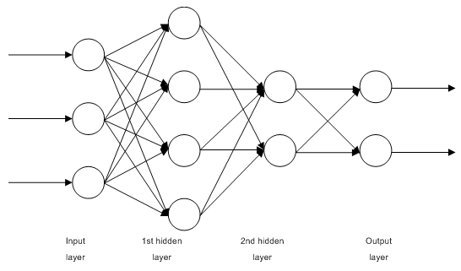
Fig. 1. Structure of a multilayer neural network
图1 一个多层神经网络结构
1.2.2. Jordan Networks are partially recurrent networks and similar to Elman networks. 乔丹网络部分回归与Elman网络相似。
It can be treated as a feedforward network with additional context neurons in the input layer.
它被视为一个在输入层附加上下文神经元的前馈网络。
These context neurons are fed by themselves (direct feedback) and from the input neurons. Context neurons preserve current state of the network. In a Jordan network the number of context and input neurons must be the same.
这些上下文神经元可以自己反馈自己（直接反馈）也可以从输入神经元。上下文神经元保护网络当前的状况。在乔丹网络中上下文和输入神经元数量必须相同。
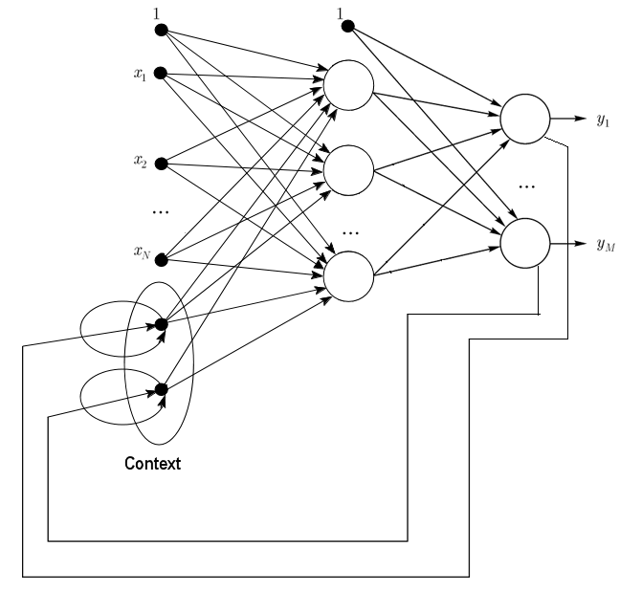
Fig. 2. Structure of a Jordan network
图2 一个乔丹网络结构
1.2.3. Elman Networks are partially recurrent networks and similar to Jordan networks. The difference between Elman and Jordan networks is that in an Elman network context neurons are fed by output neurons, not by hidden ones. Besides, there is no direct feedback in context neurons.
Elman网络部分回归与乔丹网络类似。Elman和乔丹网络的区别是，Elman网络的上下文神经元是由输出神经元反馈，而非被隐藏的某个神经元。此外，上下文神经元中没有直接反馈。
In an Elman network the number of context and hidden neurons must be the same. The main advantage of Elman networks is that the number of context neurons is defined not by the number of outputs like in Jordan network but the number of hidden neurons, which makes the network more flexible. Hidden neurons can be easily added or taken away unlike the number of outputs.
Elman网络中上下文神经元和隐藏神经元数量必须相同。Elman网络的主要优点是，上下文神经元的数量并不像乔丹网络那样取决于输出神经元数量而是隐藏神经元数量，从而使网络更加灵活。隐藏神经元可以很容易地添加或取出，这一点不像输出的数量。

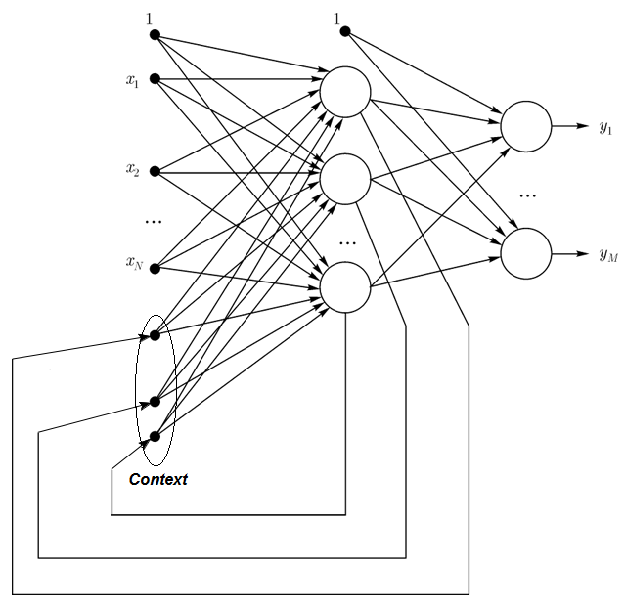
Fig. 3. Structure of an Elman network
图3 Elman神经网络结构
1.2.4. Radial Basis Function Network (RBF) - is a feed-forward neural network that contains an intermediate (hidden) layer of radially symmetric neurons. Such a neuron converts the distance from a specified input vector to its correspondent center by some non-linear law commonly taken to be Gaussian.
径向基函数网络（RBF）是一种前馈神经网络，包括一个中间（隐藏）的径向对称层神经元。这样的神经元将距离从指定的输入向量到其对应的由一些被普遍采取的高斯非线性算法中心。
The RBF networks have many advantages over multi layer feed forward networks. First of all, they emulate (not sure about the word) an arbitrary non linear function with only one intermediate layer, which saves the developer a necessity to decide on the number of layers. Then, parameters in the linear combination in the output layer can be optimized with the help of widely known methods of linear optimization. The latter work fast and do not have difficulties with local minimums that greatly interfere in backpropagation. That is the reason why the RBF network learns a lot faster than when using backpropagation.
RBF网络在多层前馈网络有许多优点。首先，他们模仿（不确定是否这个词合适）只含一个中间层的任意非线性函数，从而节省开发者决定层数的必要性。然后，在输出层的线性组合参数可以用众所周知的线性方法帮助优化。后者的工作速度快也没有反向传播里局部最小话极大干扰的困难。这就是为什么RBF网络的学习速度远快于使用反向传播。
Disadvantages of RBF: these networks have weak extrapolating characteristics and turn out to be cumbersome when the input vector is large.
RBF的缺点：这些网络有较弱的外推特性，输入向量较大时也变成了累赘。
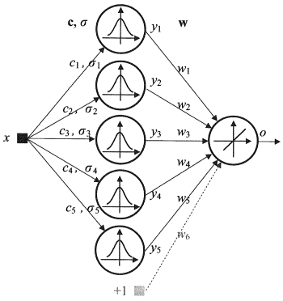
Fig. 4. Structure of an RBF
图4 RBF神经网络结构
1.2.5. Dynamic Learning Vector Quantization, DLVQ Networks are very similar to the self organizing maps (SOM). Unlike SOM, DLVO are capable of supervised learning and lack a neighborhood relationship between the prototypes. Vector quantization has a wider use than clustering.
动态学习矢量量化，DLVQ网络与自组织映射（SOM）非常相似。与SOM不同，DLVO能够监督学习，缺乏原型之间邻居关系。矢量量化比聚类有更广泛的应用。
1.2.6. Hopfield Network is a fully connected network with a symmetrical connection matrix. During operation, dynamics of such networks converge to one of the equilibrium states. These equilibrium states are local minima of functionality known as energy of the network. Such a network can be used as a content-addressable associative memory system, as a filter and for addressing some optimization challenges.
Hopfield网络是有对称连接矩阵的完全连接网络。在操作过程中，这些网络动态收敛到一个平衡状态。这些平衡态局部最小值的功能被称为网络的能量。这样的网络可以作为过滤器和解决一些优化的挑战，成为一个内容寻址联想记忆系统。
Unlike many neural networks working till they receive a response in a certain number of tacts, Hopfield networks work till they reach the equilibrium state that is when the next state of a network is exactly the same as the previous one. In this case the initial state is an input pattern and in the equilibrium state the output image is received. Training a Hopfield network requires a training pattern to be presented at the input and output layers simultaneously.
与许多神经网络工作直到他们接收到一定数量的触觉响应不同，Hopfield网络的工作直到他们到达网络下一个状态和前一个状态完全相同的平衡状态。在这种情况下，初始状态是一个输入模式，在平衡状态下输出图像被接收。训练一个Hopfield网络需要一个在输入层和输出层同时出现的训练模式。
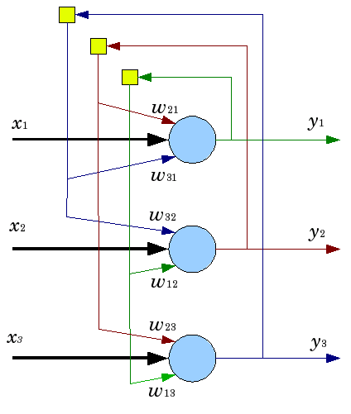
Fig. 5. Structure of a Hopfield network with three neurons
图5 三神经元Hopfield神经网络结构
Despite appealing characteristics, a classical Hopfield network is far away from being ideal. It has limited memory, around 15% of the number of neurons in the network N, whereas systems of addressed memory can store up to 2N of different images, using N bits.
尽管具有吸引人的特点，经典Hopfield网络却远离了理想。它受限于内存，一个网络中15%左右的神经元数量N，而系统的寻址存储器最多可以存储2N个不同图像，使用N个bits。
Besides, Hopfield networks are not capable of recognizing if the image is displaced or turned in relation to its initial stored position. These and other drawbacks define perception of a Hopfield network as a theoretical model convenient for study rather than a practical instrument for every day use.
此外，Hopfield网络不能识别图像移位或关系反转到其初始存储位置。这些和其他的缺陷，决定了Hopfield网络感知机为研究方便的理论模型，而不是每天使用的实用工具。
Many others (Hemming recurrent network, Grossberg network, networks of adaptive resonance theory (ART-1, ART-2) etc) were not mentioned in this article as they are outside of the scope of our interest.
其他的很多（包边递归网络，研究网络，网络自适应共振理论（ART-1，ART-2）等）不在本文提到的，都在我们感兴趣的范围之外。
1.3. Training Methods训练方法
The ability to learn new things is the main characteristic of a human brain. In the case of artificial neural networks, learning is a process of configuring network architecture (the structure of connections between neurons) and weights of synaptic links (affecting coefficient signals) to obtain effective solution for the task in hand. Usually training of a neural network is performed on a data sample. A training process follows a certain algorithm and as it goes on, the network reaction to input signals should be improving.
学习新事物的能力是人类大脑的主要特征。在人工神经网络的情况下，学习是一个配置网络架构（神经元之间的连接结构）和突触链接的权重（影响系数信号）从而获得有效的解决手头的工作的过程。通常训练神经网络要对数据样本进行。训练过程遵循一定的算法，持续进行下去，网络对输入信号的反应会提高。
There are three major learning paradigms: supervised, unsupervised and combined. In the first case the right answers for every input example are known and the weights are trying to minimize the error. Unsupervised learning allows categorizing samples through explaining the internal structure and nature of the data. In combined training both of the above approaches are used.
有三个主要的学习模式：监督，无监督和联合。在第一种情况下，对于每一个输入样本的正确答案是已知的，权重试图减少误差。无监督学习允许分类样本解释数据的内部结构和性质。联合训练使用上述两种方法。
1.3.1. Main Rules of Neural Network Learning主要的神经网络学习规则
There are four main learning rules based on the network architecture connected with them: error correction, Boltzmann's law, Hebb's rule and competitive learning.
基于网络架构有四个主要的学习规则与它们连接：误差校正，玻尔兹曼定律，Hebb规则和竞争学习。
1.3.1.1. Error Correction误差校正
Every input example has a specified desired output value (target value), which may mismatch a real (forecast) value. The error correction learning rule is using the difference between the target and the forecast values for direct adjustment of weights in order to decrease the error. Training is carried out only in the case of an erroneous outcome. This learning rule has numerous modifications.
每一个输出样本有一个指定期望输出值（目标值），此值可能不匹配一个真实（预测）值。误差校正学习规则，目标和预测值之间的差值直接调整权重值以减小误差。训练仅在错误结果下进行。这种学习规则有许多变体。
1.3.1.2. Boltzmann's Rule玻尔兹曼规则
Boltzmann's rule is a stochastic learning rule by analogy with thermodynamic principles. This results in adjusting neurons' weight coefficients according to the desired probabilistic distribution. Learning Boltzmann's rule can be considered as an isolated case of correction by an error where an error means a correlation discrepancy of the states in two modes.
玻尔兹曼的规则是由模拟热力学原理的随机学习规则。这一结果导致根据所需的概率分布调节神经元的权重系数。学习玻耳兹曼的规则可以被视为修正错误的一个孤立案例，错误在这里意味着两种状态的相关性差异。
1.3.1.3. Hebb's Rule Hebb规则
Hebb's rule is the most famous algorithm of neural networks learning. The idea of this method is that if neurons on both sides of a synapse activate simultaneously and regularly, then the strength of the synaptic connection increases. An important peculiarity here is that synaptic weight change depends only on the activity of the neurons connected with this synapse. There are many variations of this rule that differ in peculiarities in synaptic weight modification.
Hebb规则在神经网络学习算法中最为著名。这种方法的思想是：如果神经元在双方同时突触激活并且不断，突触连接强度将提高。这里的一个重要特点是，突触权重变化只取决于神经元连接这个突触的活动。这个规则根据突触权重值修正的特点有很多变体。
1.3.1.4. Competitive Learning 竞争学习
Unlike Hebb's learning rule, where a number of output neurons can activate simultaneously, here output neurons compete against each other. An output neuron with maximal value of weighed sum is the "winner" and "the winner takes it all". Outputs of other output neurons are set to inactive. When learning, only the weights of the "winner" get modified targeting increasing proximity to the current input instance.
不像Hebb学习规则，数个输出神经元可以同时激活，这里的输出神经元相互竞争。拥有最大权重加和值的输出神经元是“赢家”并且“胜者为王”。其他的输出神经元的输出设置为无效。学习的时候，只有“赢家”的权重得到修正，目标越来越接近当前的输入实例。
There are a lot of learning algorithms addressing different problems. Backpropagation, one of the most efficient modern algorithms, is one of them. The principle behind it is that synaptic weight change takes place with consideration for local gradient of the error function.
有很多算法解决不同的学习问题。反向传播，就是其中目前最有效的算法之一。它背后的原理是，突触权重根据误差函数的局部梯度发生变化。
The difference between real and correct responses of a neural network evaluated at the output layer is back propagated - towards the stream of signals (Fig.5). This way every neuron can define contribution of its weight to the cumulative error of the network. The simplest learning rule is the steepest descent method, that is synaptic weight change proportionally to their contribution to the cumulative error.
真实和神经网络在输出层评估的修正反应之间的差值是反向传播 – 朝向信号流（图5）。这样，每个神经元可以定义其权重在网络中累计误差的贡献。最简单的学习规则是梯度下降法，即突触权重值按比例改变累积误差的贡献。
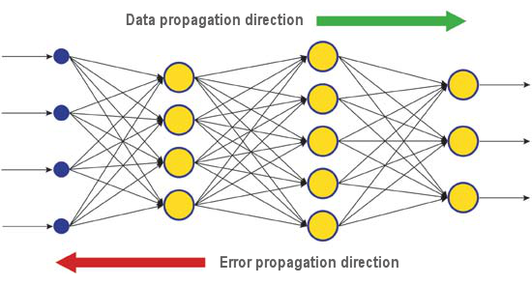
Fig. 6. The pattern of data and error diffusion in a network when learning through backpropagation
图6 数据和误差在网络通过反向传播学习时扩散的模式
Surely, this type of neural network learning does not ensure the best learning result as there is always a possibility that the algorithm got into a local minimum. There are special techniques allowing to knock out the found solution from a local extreme point. If after a few applications of this technique the neural network has the same decision, then it can be concluded that the found solution is most likely to be optimal.
当然，这类神经网络的学习并不能保证最佳的学习效果，因为总有一种可能是使算法陷入局部最小。有特殊的技术允许击出局部极值点的解决方案。如果几种应用这种技术的神经网络具有相同的决策，那么可以得出结论，找到的解决方案有可能是最优的。
1.4. Disadvantages 缺陷
The main difficulty of using neural networks is the so called "curse of dimensionality". When input dimensions and the number of layers are increased, the complexity of a network and learning time are growing exponentially and the received result is not always optimal.
应用神经网络的主要困难是所谓的“维数灾难”的诅咒。当输入的尺寸和层数的增加，网络的复杂性和学习时间呈指数增长，收到的结果往往却并不是最优的。
Another difficulty of using neural networks is that traditional neural networks are unable to explain how they are solving tasks. In some application fields like medicine this explanation is more important than the result itself. Internal result representation is often so complex that it is impossible to analyze except simplest cases that are usually of no interest.
使用神经网络的另一个难点是，传统的神经网络无法解释他们是如何解决任务。在一些应用领域如医学领域这个解释比结果本身更重要。内部结果表示往往是复杂到不可能分析出除了那些通常没有兴趣的简单情况。

Deep Learning 深度学习
Today theory and practice of machine learning is going through a "deep revolution", caused by successful implementation of the deep learning methods, representing third generation neural networks. Unlike classical second generation networks used in 80s-90s of the last century, new learning paradigms resolve a number of problems that restricted expansion and successful implementation of traditional neural networks.
如今机器学习的理论和实践正在经历一个“深刻的革命”，这是通过深度学习方法的成功实施造成的，它代表了第三代神经网络。不同于传统的上世纪80-90年代的第二代网络，新的学习方法解决一系列制约扩张和传统神经网络成功的实现问题。
Networks trained with deep learning algorithms did not simply excelled best alternative methods in accuracy but in some cases revealed rudiments of understanding sense of the input information. Image recognition and text information analysis are the brightest examples.
网络应用深度学习算法训练，并不只是简单地超越最好的替代方法，还可以在某些情况下展现初步理解意义上的输入信息。图像识别和文本信息的分析是展现其最聪明方面的例子。
Today the most advanced industrial methods of computer vision and speech recognition are based on deep networks. Giants of the IT industry like Apple, Google, Facebook are employing researchers developing deep neural networks.
如今，计算机视觉和语音识别上最先进的工业方法就是基于深层网络。IT行业巨头如苹果，谷歌，Facebook都雇佣了研究人员开发深度神经网络。
2.1. Background 背景
A team of graduate students studying at the University of Toronto led by Professor Geoffrey E. Hinton won the top prize in a contest sponsored by Merck. Using a limited data set, describing the chemical structure of 15 molecules, G. Hinton's group managed to create and apply a special program system that defined which of those molecules was most likely to be an effective medicine.
一个多伦多大学的研究生团队在Geoffrey E. Hilton教授的带领下赢得了Merck最高奖。他们使用有限数据集描述了15分子的化学结构，G. Hinton的团队成功创建和应用特殊的程序系统，定义了哪些分子很可能是一种有效的药。
The peculiarity of that work was that the developers used an artificial neural network based on deep learning. As a result that system managed to carry out calculations and research based on a very limited set of source data whereas training a neural network normally requires a significant amount of information put in the system.
这项工作的特点是，开发人员使用基于深度学习的人工神经网络。系统管理的结果是，对非常有限的数据源进行计算和研究，而训练一个神经网络通常需要向系统中放入大量的信息。
Hinton's team achievement was particularly impressive because the team decided to enter the contest at the last minute. Added to that, the deep learning system was developed with no specific knowledge about how the molecules bind to their targets. Successful implementation of deep learning was yet another achievement in artificial intelligence development of the eventful 2012.
Hinton团队的成就令人印象深刻，因为团队在最后一刻才决定参加比赛。另外，深度学习系统对分子如何结合到他们的目标没有具体的认识。深度学习的成功实施在重要的2012年也成为了人工智能发展的另一个成就。
So in summer 2012, Jeff Dean and Andrew Y. Ng from Google presented a new image recognition system with accuracy rate 15,8%, where to train a cluster system of 16,000 nodes they used the ImageNet network containing a library of 14 million pictures of 20,000 different objects. Last year a program created by Swiss scientists outperformed a human in recognizing images of traffic signs. The winning program accurately identified 99.46 percent of the images in a set of 50,000; the top score in a group of 32 human participants was 99.22 percent, and the average for the humans was 98.84 percent. In October 2012, Richard F. Rashid, a coordinator of Microsoft scientific programs presented at a conference in Tianjin, China a technology of simultaneous translation from English into Mandarin accompanied by a simulation of his own voice.
之后在2012年夏天，谷歌的Jeff Dean和Andrew Y. Ng提出了一个新的准确率达到15.8%图像识别系统，在训练时他们使用了16000个节点的集群系统ImageNet网络包含一个1400万张涉及20000种不同的物体的照片库。去年，瑞士科学家创造的程序优于人类的道路交通标志图像识别。获胜的程序精确地确定了一组50000张图像中的的百分之99.46； 32人参加的小组中的最高得分为百分之99.22，人类平均值为百分之98.84。2012年十月，微软科学计划的协调员Richard F. Rashid在天津的一个会议上展示了，中国的同声传译技术同时模拟他的声音。
All these technologies demonstrating a breakthrough in the field of artificial intelligence are based on the deep learning method to certain extent. The main contribution to the deep learning theory is being made by professor Hinton, a great-great grandson of George Boole, an English scientist, founder of the Boole algebra underlying contemporary computers.
所有这些技术在人工智能领域表现出的突破在一定程度上是基于深度学习的方法。深度学习理论的主要贡献者是由Hinton，他是伟大的英国科学家发现了布尔代数，现代电脑创始人George Boole的曾孙。
The deep learning theory supplements ordinary methods of machine learning with special algorithms for the input information analysis at several presentation levels. The peculiarity of the new approach is that deep learning studies the subject till it finds enough informative presentation levels to account for all the factors that can influence parameters of the object in question.
深度学习理论用特殊的针对输入信息在一些表现水平上分析的算法，补充了机器学习的普通方法。新方法的特点是,深入学习研究某个问题，直到它找到足够的信息表示水平可以被视为所有能够影响问题中对象参数的因素。
This way, a neural network based on such an approach requires less input information for learning and a trained network is capable of analyzing information with a higher level of accuracy than usual neural networks. Professor Hinton and his colleagues state that their technology is especially good for searching peculiarities in multi-dimensional, well structured arrays of information.
这样，基于这一方法的神经网络就需要更少的输入信息进行学习和训练的网络能够比一般的神经网络更高级别的精度分析。Hinton和他的同事们指出他们的技术在多维特征搜索特别好，对结构的阵列信息也表现良好。
The artificial intelligence technologies (AI), particularly deep learning, are widely used in different systems, including the intelligent personal assistant Apple Siri based on the Nuance Communications technologies and recognizing addresses in the Google Street View. Nevertheless, scientists are estimating success in this sphere very carefully as the history of creating an artificial intelligence is full of optimistic promises and disappointments.
人工智能（AI）技术，特别是深度学习，广泛应用于不同的系统，包括苹果基于Nuance通信技术的智能个人助理Siri和识别在谷歌街景地址。然而,科学家们非常谨慎的预估成功,因为过去对于创造人工智能充满了乐观却换来了失望。
In the 1960s, scientists believed that it would take only 10 years to create a fully featured artificial intelligence. Then in the 1980s, there was a wave of young companies offering a "ready-made artificial intelligence" followed by the "ice age" in this sphere, which lasted up to recently. Today wide computational capabilities available in cloud services provide a new level of powerful neural network implementation using new theoretical and algorithmic base.
在上世纪60年代，科学家们认为只需要10年就能创建一个全功能的人工智能。然后，在上世纪80年代，有一批年轻的公司提供“现成的人工智能”，然后这个领域就进入“冰河世纪”，一直持续到最近。今天具有广泛的计算能力的云服务应用新的理论和算法基础提供了强大的神经网络实现。
It should be noted that neural networks, even third generation ones like convolutional neural networks, autoassociators, Boltzmann machines, have nothing in common with biological neurons except the name.
应该指出的是，神经网络，甚至第三代的卷积神经网络，自联想模型(autoassociators)，Boltzmann机，除了名字与生物神经元相似之外，没有任何共同之处。
The new learning paradigm implements the learning idea in two stages. At the first stage, information about internal structure of the input data is extracted from a large array of unformatted data with autoassociator through layer-by-layer unsupervised training. Then, using this information in a multi-layer neural network, it goes through supervised training by known methods using formatted data. At the same time, the amount of unformatted data should be as large as possible. Formatted data can be a lot smaller in size. In our case it is not of immediate importance.
新的学习模式通过两个阶段实现学习理念。在第一阶段，输入的数据信息的内部结构，是从大量的非格式化数据的自联想模型，通过层层监督训练提取。然后，在一个多层神经网络的使用这些信息，它通过监督训练用已知的方法使用格式化数据。同时，对非格式化数据的数量应尽可能大。格式化的数据可以小很多。在我们的例子中不是直接重要的。
2.2. Autoencoders. Autoencoder and Restricted Boltzmann Machine. Differences and Peculiarities 自编码和受限玻尔兹曼机 差异性和特殊性
2.2.1. Autoencoder 自编码
The first autoassociator (AA) was a Fukushima neocognitron. 第一个自联想模型（АА）是福岛神经认知机
Its structure is presented at Fig.7. 其结构如图7所示。

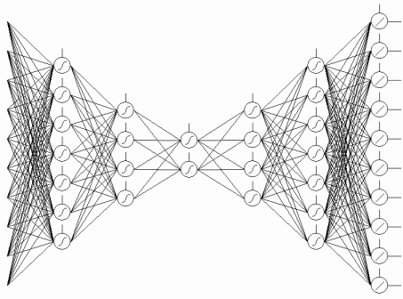
Fig. 7. A Fukushima neocognitron
图7 福岛神经认知机
The purpose of an autoassociator (AA) is to receive at the output as precise image of the input as possible.
自联想模型（АА）的目的是尽可能将得到的输出作为精确图像的输入。
There are two types of АА — generating and synthesizing. A restricted Boltzmann machine belongs to the first type and an autoencoder represents the second type.
有两种自联想类型——生成和合成。受限玻尔兹曼机属于第一类而第二类用自编码表示。
An autoencoder is a neural network with one open layer. Using unsupervised learning algorithm and back propagation, it sets a target value equal to the input vector, i.e.y = x.
自编码是有一个开放层的神经网络。使用无监督算法和反向传播学习，设定一个目标值等于其输入向量，即y = x
An example of an autoencoder is presented on Fig.8.
一个自编码例子展示在图8。
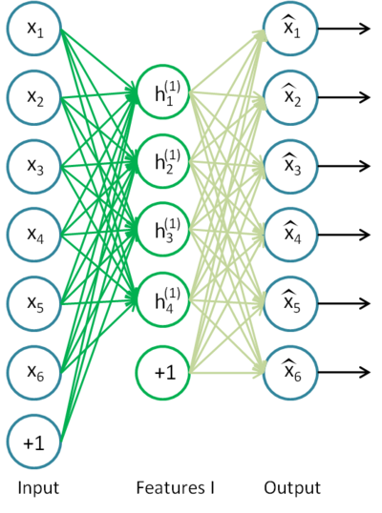
Fig. 8. An autoencoder structure
图8 一个自编码结构
Autoencoder is trying to construct the function h(x)=x. In other words it is trying to find an approximation of a function ensuring that a neural network feedback is approximately equal to the values of input parameters. For the solution of the problem to be nontrivial, the number of neurons in the open layer must be less than the dimension of the input data (like on the picture).
自编码试图构建函数 h（x）= X。换句话说，它试图找到一个近似的函数保证神经网络的反馈近似等于其输入参数值。为解决这一问题的是很普通的，打开层的神经元数目必须小于输入数据的维数（如图中所示）。
It allows to compress data when the input signal gets passed to the network output. For example, if the input vector is a set of brightness levels of an image 10х10 pixels in size (100 characteristics), the number of neurons of the hidden layer is 50, the network is forced to learn to compress the image. The requirement h(x)=x means that based on the activation levels of fifty neurons of the hidden layer, the output layer is to restore 100 pixels of the initial image. Such compression is possible if there are hidden interconnections, characteristic correlation or any structure at all. This way an autoencoder operation reminds the principal component analysis method (PCA) in the sense that input data gets reduced.
输入信号被传递到网络输出时可以压缩数据。例如，如果输入向量是一组10х10像素的亮度水平的图像（100个特征），隐层神经元个数为50，网络会被强制学习压缩图像。等式h（x）= X 意味着，基于隐藏层有50个神经元的激活水平下，输出层要恢复原始图像的100个像素。如果有隐藏层互联，特征相关性或者特征结构，这样的压缩就是可行的。这样一个自编码操作，提醒主成分分析法（PCA）对于减少输入数据有意义。
Surprisingly, experiments conducted by Bengio et al. (2007), showed that when training with the stochastic gradient descent, nonlinear autocoding networks with the number of hidden neurons greater than the number of inputs (also called "superabundant") had useful presentation in the light of the conformance error of the network that took that presentation from the input.

令人惊讶的是，通过Bengio等人进行的实验（2007），表明随机梯度下降训练时，非线性自动编码网络隐层神经元的数量大于输入的数（也叫“有余”）已经有效的显示了网络从输入的一致性误差了。
Later, when the idea of sparsity appeared, a sparse autoencoder was widely used.
后来，当稀疏的想法出现时，稀疏自编码就被广泛使用了。
A sparse autoencoder is an autoencoder that has a number of hidden neurons significantly greater than the input dimension but they have a sparse activation. A sparse activation is when the number of inactive neurons in the hidden layer is significantly greater than the number of active ones. If we describe sparsity informally, then a neuron can be considered active if the value of its function is close to 1. If a sigmoid function is in use, then for the inactive neuron its value must be close to 0 (for the function of hyperbolic tangent the value should be close to -1).
稀疏自编码是隐藏神经元的数目明显大于输入维数的一种自编码，但他们有一个稀疏激活。稀疏激活是当隐藏层的不活跃神经元数目明显大于活跃神经元数量。如果我们非正式地描述稀疏，如果一个神经元的函数值接近1的时候，它可以被认为是活跃的。如果使用Sigmoid函数，不活跃值必须接近0(双曲正切函数值应该接近-1)。
There is a variation of an autoencoder called denoising autoencoder (Vincent et al., 2008). This is the same autoencoder but its training has some peculiarities. When training this network, "corrupted" data are input (some values are substituted with 0). At the same time, there is "correct" data to compare with the output data. This way an autoencoder can restore damaged data.
自编码有一个变种称为去噪自编码（Vincent等人，2008）。这是相同的自编码但是训练有一些特点。训练该网络时，输入的是“损坏”的数据(一些值被0取代)。同时，“正确”的数据将与输出数据进行比较。这样自编码就可以恢复损伤的数据。
2.2.2. Restricted Boltzmann Machine, RBM. 受限玻尔兹曼机，RBM。
We are not going to focus on the history of a restricted Boltzmann machine (RBM). All we need to know that it started with recurrent neural networks with feedback that were very difficult to train. Due to this learning difficulty, more restricted recurrent models appeared so simpler learning algorithms could be applied. A Hopfield neural network was one of such models. John Hopfield was the person who introduced the concept of the network energy having compared neural network dynamics with thermodynamics.
我们不会关注受限玻尔兹曼机（RBM）的历史。我们只需要知道，他和非常难于训练的反馈递归神经网络同时产生。基于这种学习难度，限制更强的递归模型出现使简单的学习算法可以被应用。Hopfield神经网络就是这样的一个模型。John Hopfield介绍了网络能量的概念，用于比较神经网络动力学和热力学。
The next step on the way to an RBM was regular Boltzmann machines. They differ from a Hopfield network in having stochastic nature and its neurons are divided into two groups describing visible and hidden states (similar to a hidden Markov model). A restricted Boltzmann machine is different from a regular one in absence of connections between the neurons of one layer.
RBM之后产生了定期玻尔兹曼机。它们和Hopfield网络不同在于，它们具有随机性，它的神经元分为可见和隐藏两种状态(类似隐藏马尔可夫模型)的组。受限玻尔兹曼机和常规玻尔兹曼机的不同在于没有神经元和一层之间的连接。
Fig. 9 represents an RBM structure. 图9展示了一个RBM结构。
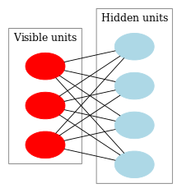
Fig. 9. An RBM structure
图9 一个RBM结构
The peculiarity of this model is that in the present states of neurons of one group, the states of neurons of another group are going to be independent of one another. Now we can move on to some theory where this property has the key role.
这种模式的特点是，一组神经元的现状相对于另一组是彼此独立的。现在我们可以继续一些理论，这一性质具有关键作用。
Interpretation and objective 解释和目的
An RBM is interpreted similar to a hidden Markov model. We have a number of states that we can observe (visible neurons) and a number of hidden states that we cannot directly see (hidden neurons). We can come to a probability based conclusion about the hidden states relying on the states that we can observe. After such a model has been trained, we get an opportunity to draw conclusions regarding visible states knowing that the hidden ones are following Bayes' theorem. This allows generating data from the probability distribution used for training the model.
RBM被解释为类似隐式马尔可夫模型。我们有一些可以观察的状态（可见神经元）和一些我们不能直接看到的隐藏的状态（隐藏神经元）。我们可以得到一个基于“隐藏状态依赖我们可以观察到的状态”论断的概率。这样的模型训练后，我们得到一个机会来得出可见状态了解隐藏状态是遵循贝叶斯定理的结论。这允许从用概率分布来训练模型而生成数据。
This way we can formulate the objective of training a model: the model parameters are to be adjusted the way so a restored vector from the initial state is closest to the original. A restored vector is a vector received by a probabilistic inference from hidden states, which in their turn, were received by a probabilistic inference from visible states, i.e. from the original vector.
这样我们可以指定一个训练模型的目的：模型参数遵从于从初始状态重置的向量接近原始状态来进行调整。重置向量是一个收到隐藏状态概率推理的向量，而它们又受到可见状态的概率推理，即从原始向量。
Training algorithm is Contrastive Divergence CD-k 训练算法的对比差异CD-k
This algorithm was invented by Professor Hinton in 2002 and is remarkably simple. The main idea is that mathematical expectation values are substituted by defined values. Introduced is the idea of Gibbs sampling.
该算法是由Hinton 教授在2002年发明的，它非常简单的。其主要思想是数学期望值由定义值取代。介绍了Gibbs采样思想。
The CD-k looks like: CD-K看起来像：
- The state of visible neurons is set equal to the input pattern; 可见神经元的状态被设置为等于输入模式；
- Probabilities of the hidden layer states are drawn; 绘制了隐层状态的概率；
- Each neuron of the hidden layer is assigned the state "1" with probability equal to its current state; 隐藏层的每个神经元被指定为状态“1“，概率等于其当前状态。
- Probabilities of the visible layer states are drawn based on the hidden layer; 可见层状态的概率基于隐藏层绘制；
- If the current iteration is less than k, then return to step 2; 如果当前迭代小于k，就返回到步骤2；
- Probabilities of the hidden layer states are drawn;隐层状态的概率被绘制出；
In Hinton's lectures it looks like: Hinton的讲座看起来如下：
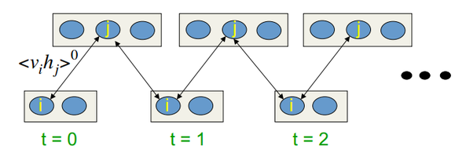
Fig.10. Algorithm of the CD-k learning
图10 CD-k学习算法
In other words, the longer we are doing sampling, the more precise the gradient is. Professor states that the result received for CD-1, i.e. only one sampling iteration, is already good.
换句话说,我们所做抽样的时间越长,梯度更精确。教授指出,结果收到CD-1,即只有一个采样迭代已经完成。
2.3. Stacked Autoassociators Networks. Stacked Autoencoder SAE, Stacked Restricted Boltzmann Machine (Stacked RBM) 堆叠自联想网络。堆叠自编码SAE，堆叠受限玻尔兹曼机（堆叠RBM）
For extracting high level abstractions from the input data set, autoassociators are combined into a network.
从输入数据中提取高层抽象的集合，再由自联想组合成一个网络。
Fig. 11 represents a stacked autoencoder structure and a neural network, which together represent a deep neural network with weights initialized by a stacked autoencoder
图11表示一个堆叠自编码结构和一个神经网络，这是一个由堆叠自编码初始化权重的深度神经网络。
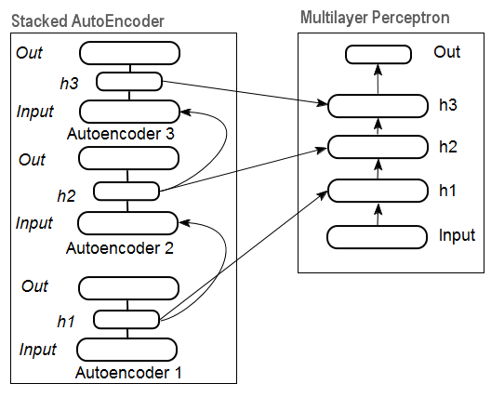
Fig. 11. Structure of a DN SAE
图11 一个DN SAE结构
On Fig.12 there is a pattern of a stacked RBM (SRBM) and a neural network, which together represent a deep neural network with weights initialized by SRBM.
图12 堆叠RBM模式（SRBM）和一个神经网络，这是一个由SRBM初始化权重的深度神经网络。
These illustrations of deep network structures emphasize the fact that the information gets extracted from bottom to top.
这些深度网络结构插图强调了信息从下至上被提取的事实。
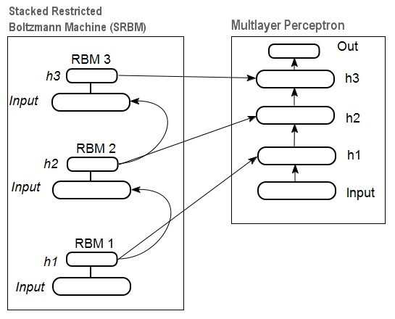
Fig. 12. Structure of a DN SRBM
图12 一个DN SRBM结构
2.4. Training of Deep Networks (DN). Stages. Peculiarities 深层网络（DN）培训。阶段。特点
Training deep networks comprises two stages. At the first stage, an autoassociator network (SAE or SRBM, depending on the DN type) receives unsupervised training on an unformatted data array. After that, hidden layer neurons of ordinary MLP get initialized by the hidden layer weights received after training. Fig. 11 and Fig. 12 represent a pattern of the learning and transfer processes. After training of the first АЕ/RBM, neuron weights of the hidden layer become inputs of the second one etc. This way, generalizing information about the structure (line, contour, patter etc) gets extracted from data.
训练深度网络包括两个阶段。在第一阶段，自联想网络（SAE或SRBM，取决于DN类型型）接收无监督对未格式化的数据数组的训练。然后，普通MLP隐藏层神经元可以通过训练后得到的加权值初始化。图11和图12代表的学习和迁移过程的模式。第一次АЕ/ RBM训练后，隐层神经元的加权值成为第二次训练的输入值，概括的结构（线，轮廓，模式等）信息从数据中提取。
The second stage is the time for fine-tuning of the MLP (supervised training) on formatted data set using well known methods. Practice proved that such initialization sets the neuron weights of the hidden layers of the MLP to the global minimum and the following fine-tuning takes a very short time.
第二阶段将针对MLP（监督学习）在格式化数据组下以众所周知方法进行的微调。实践证明，这样的初始化设置了MLP的隐层神经元的加权值为全局最小值，使得之后的微调花费的时间很短。
Moreover, for deep networks with the number of layers greater than three, D. Hinton suggested that fine-tuning should be conducted in two stages. At the first stage only two upper layers should be trained and at the second one the rest of the network.
此外，对于层数大于三的深度网络，D. Hinton建议微调应分两个阶段进行。第一阶段，只有两个顶层应该被训练，第二阶段训练网络中其余的层。
It should be mentioned that a SRBM has less stable results of unsupervised training than a SAE.
应该说，无监督训练下SRBM训练结果比SAE得到稳定性稍差的结果。
Note. Very often these terms are confused. A SRBM is identified with a deep belief network DBN. Despite the fact that a RBM derived from a DBN, these are totally different structures. A DBN is a multilayer neural network, with neuron weights of hidden layers initialized randomly by binary patterns.
注意。这些术语经常使人感到困惑。SRBM被认为是一个深度信念网络DBN。尽管RBM来自于DBN，却有完全不同的结构。DBN是一个隐藏层神经元加权值被二进制模式随机初始化的多层神经网络。
- Practical Experiments 现实试验
Deep networks will be performed in R. 深度网络在R语言中执行
3.1. The R Language R语言
History. R is a programming language and an environment for statistic computations and charting, developed in 1996 by New Zealand scientists Ross Ihaka and Robert Gentleman in Aokland University.
历史：R是一种编程语言和统计计算和绘图的环境，1996年新西兰科学家Ross Ihaka和Robert Gentleman先生在奥克兰大学开发的。
R is a GNU project that is a free software and its philosophy goes down to the following principles:
R是一个GNU项目，这是一个自由软件及其哲学遵循以下原则：
- freedom to launch programs for any purpose (freedom 0); 自由地为任何目的运行程序（自由0）；
- freedom to learn how a program works and adapt it for own needs (freedom 1); 自由地学习程序是如何工作的，以及应用到自己需要的地方（自由1）；
- freedom to distribute copies to help others (freedom 2); 自由地发布副本来帮助他人（自由2）；
- freedom to improve the program and let society benefit from the improvements. 自由地改善程序，并从而改善社会效益。
In the historical perspective, R is an alternative for the implementation of S. The latter was developed by John Chambers and his colleagues in the Bell Labs company in 1976. Today, R is still being improved by R Development Core Team including John Chambers.
在历史的角度看，R语言是S语言的另一种实现。后者是由John Chambers和他Bell实验室公司的同事们于1976年开发的。今天，R语言依然由包括John Chambers在内的R开发核心团队进行维护和改进。
To repeat experiments, you will need to install R and Rstudio. Information on where to download and how can be found on the internet. If there are any questions, we can discuss them in the comments to the article.
为了重复实验，你需要安装R和RStudio。关于那里去下载和如何下载，可以在互联网上找到。如果有任何问题，我们可以在此文章以下的评论中讨论。
Advantages of R: R语言的优势：
- Today R is the standard in statistic computations. R是现今统计计算的标准
- It is being developed and supported by the global scientific community of universities. 它正在受到全球科学界高校间的开发和支持。
- Broad set of packages for all advanced fields of data mining. The time between a publication of the idea and its implementation in the R package is usually no longer that 2 weeks. 数量众多的包为先进的数据挖掘领域提供帮助。想法和实现到出版R包之间需要的时间往往不到2星期。
- And last but not the least, it is absolutely free. A famous developer of a free OS said once: "Programs are like sex - it is better when it is free". 最后的但却并非不重要的，他完全免费。一个著名的免费操作系统开发者曾说：“程序和性一样——免费才是最好的。”
3.2. Implementation Variations and Issues Addressed 实现的方式和解决问题
There are two possible ways of implementation.有两种可能方式来实现。
The first one involves using unique programs by John Hinton for Matlab. For that the "R.matlab" is required. This package has the writeMat() and readMat() methods for reading and writing the MAT files. It enables communication (code implementation, sending and receiving objects etc) from Matlab v6 and higher launched locally or on the remote host in the client-server link. Details can be found in the package description. This is the way for those who are comfortable using Matlab. I have not tried using this method but there is a possibility to link Matlab and MQL this way.
第一个涉及使用独特的程序，John Hinton的MATLAB。此时”R.matlab”是必须的。这个包含有wirteMat()和readMat()方法用来读取和书写MAT文件。它允许从MATLAB v6和更高版本在本地或者远程主机上的客户端-服务器链接。详情可以在包描述中找到。这是那些习惯于使用MATLAB的方法。我们没有尝试过这种方法，但是链接Matlab和MQL的方法是可行的。
The second way of implementation is to use the R packages on this topic. We are going to explore it.
第二种实现的方法是本文中的使用R软件。我们将会探索这种方式。
There are three packages I know are connected with the topic of this article:
我知道的有三个包与本文的主题相关：
- "deepnet"is a simple package implementing the DN SAE and DN SRBM models. The length of the input data set at supervised and unsupervised learning is the same. Does not give an opportunity to perform fine-tuning of the system in two stages. Used for exploration and testing of the models at the beginning.
“deepnet”是一个简单的包用于实现DN SAE和DN SRBM模型。输入数据集的长度在有监督和无监督学习下是相同的。对执行微调系统的两个阶段不给一个机会。用于初期的探索和测试模型。
"darh" is an advanced and wide ranging package for modeling for DN SRBM. There is a model for DN SAE but I failed to launch it. This package is for experienced users, it allows creating and tuning a model of any complexity level. It is based on the unique programs by Hinton in the m language for MatLab.
“darh”是一个高级并且广泛使用的包，用于DN SRBM的建模。有一个DN SAE模型，但是我没有成功启动它。这个包是给有经验的用户使用的，它允许创建和调整任意复杂层次的模型。这是基于Hinton的使用M语言的独立软件Matlab。
"H2O" is an extensive package for training deep networks (not only them) on large data sets (>1 Гб) written in csv files.
“H2O”是训练深层网络（不只是它们）广泛使用的包，用于处理大型数据集（> 1Гб）的CSV文件。
In the below experiments we are going to use the "deepnet" package.
在下面的实验中我们将使用“deepnet”包。
3.3. Preparing Input and Target Data for the Experiment 准备实验所需的输入和目标数据
Today data mining has a certain work order:
现今的的数据挖掘有一套固定的工作顺序：
- Selecting input data (studying, analysis, preliminary preparation, evaluation). Breaking data into the training, validation and test sets (samples); 选择输入数据（研究，分析，前期的准备，评价）。将数据分为训练，验证和测试集（样本）；
- Training a model on the training data set and selecting a model/models on the validation one; 对训练数据集训练一个模型，选择（一个）验证模型；
- Evaluation of the model/models quality on the test sample and defining optimal model parameters or the best model out of the set by certain measures; 对测试样本评价模型的质量，对规定的措施定义最优模型参数或最优模型；（？）
- Letting the model/models to start the work. 让模型开始工作。
The first stage is the most time consuming and very important for the end result. To be fair, this stage is not formalized and generally speaking it is nearly an art form. A lot depends on the experience of a researcher. However! Obtaining quantitative evaluations of the input data set for selecting the most important ones is very important. Automatic selection of the best variables for a certain model is even better in this case. R provides extensive functionality for meeting challenges at all stages.
第一阶段最耗时间，对最终结果也是最为重要。公平的说，这个阶段是非正式地，一般来说几乎是一种艺术形式。这很大程度上取决于研究正的经验。然而！获取对选择的最重要输入数据源的定量评估是非常重要的。自动选择最佳变量对特定模型甚至可能在这种情况下更好。R在面对挑战的所有阶段都提供了广泛的功能。
Source data is not only very important but also has a lot of aspects to consider. It deserves a separate article. Since the goal of this article is to tell about a complex thing in very simple words, we will discuss important points but will not go into much detail.
源数据不仅非常重要，而且也有很多方面需要考虑。应该为此写一篇单独的文章。因为本文的目的是用简单的语言来讲述一个复杂的东西，我们讨论重点，但不会过多关注细节。
3.3.1. Source Data 源数据
For our classification we need a set of independent (input) variables and a target variable. Since the main pronounced advantage of deep networks is their ability to quickly learn on large input samples, let us create a set of input data comprising 17 predictors (11 indicators). ZigZag has a role of the target variable. Download in the R environment vectors of the Open, High, Low, Close quotes 4000 bars deep. The way to do it is discussed below in the description of writing an indicator. At this stage it is not important. All further computations will be performed in R.
为了分类，我们需要一套独立的（输入）变量和目标变量。由于深层网络的主要的明显优势是其在大输入样本的快速学习能力，让我们创造一套包括17个预测器的输入数据（11个指标）。ZigZag指标有一个目标变量的作用。下载到R环境下4000根K线深度的OHLC矢量。解决办法是如下描述中的关于编写一个指标的讨论。在这个阶段并不重要。所有进一步的计算都将在R中完成。
Construct a matrix out of 4 vectors, average price and size of the bar body. Turn it into a function:
构建一个包含4个向量，平均价格和实体长度的矩阵。把它作为一个函数：
pr.OHLC <- function (o, h, l, c)
{
#Unite quote vectors into a matrix having previously expanded them
#Indexing of time series of vectors in R starts with 1.
#Direction of indexing is from old to new ones.
price <- cbind(Open = rev(o), High = rev(h), Low = rev(l), Close = rev(c))
Med <- (price[, 2] + price[, 3])/2
CO <- price[, 4] - price[, 1]
#add Med and CO to the matrix
price <- cbind(price, Med, CO)
}
See the result (state at 08.10. 14 12:00) 观察到的结果（14年08月10日中午12点）
> head(price)
Open High Low Close Med CO
[1,] 1.33848 1.33851 1.33824 1.33844 1.338375 -4e-05
[2,] 1.33843 1.33868 1.33842 1.33851 1.338550 8e-05
[3,] 1.33849 1.33862 1.33846 1.33859 1.338540 1e-04
[4,] 1.33858 1.33861 1.33856 1.33859 1.338585 1e-05
[5,] 1.33862 1.33868 1.33855 1.33855 1.338615 -7e-05
[6,] 1.33853 1.33856 1.33846 1.33855 1.338510 2e-05

3.3.2. Input Data (Predictors) 输入数据（预测）
List the indicators. Indicators were selected randomly, with no preferences to gain maximal difference of input sizes.
指标列表。指标是在没有偏好获得输入尺寸最大的差异下随机选择的。
Calculation of all indicators is performed using the "TTR" package containing numerous indicators.
所有指标讲将在“TTR”包下进行，此包包含许多指标。
3.3.2.1. Welles Wilder's Directional Movement Index - ADX(HLC, n) - 4 out (Dip, Din,DX, ADX) ADX（HLC，n） 4个输出值（DIP，DIN，DX，ADX）
Compute and see what it looks like on the first 200 bars: 计算并观察最开始的200根K线的结果：
> library(TTR)
> adx<-ADX(price, n = 16)
> plot.ts(head(adx, 200))
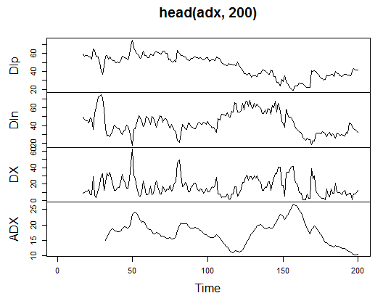
Fig. 13. Indicator Welles Wilder's Directional Movement Index - ADX(HLC, n)
图13 ADX（HLC,n）
> summary(adx)
DIp DIn DX ADX
Min. :15.90 Min. : 5.468 Min. : 0.00831 Min. : 5.482
1st Qu.:41.21 1st Qu.: 33.599 1st Qu.: 8.05849 1st Qu.:14.046
Median :47.36 Median : 43.216 Median :16.95423 Median :18.099
Mean :47.14 Mean : 46.170 Mean :19.73032 Mean :19.609
3rd Qu.:53.31 3rd Qu.: 55.315 3rd Qu.:27.97471 3rd Qu.:23.961
Max. :80.12 Max. :199.251 Max. :81.08751 Max. :52.413
NA's :16 NA's :16 NA's :16 NA's :31
In the beginning of the matrix there are 31 undefined values (NA). Then perform same calculations for all indicators without detailed explanations.
在矩阵开始有31未定义值（NA）。然后进行同样的计算，所有指标没有详细解释。
3.3.2.2. aroon(HL, n) - 1 out (oscillator) aroon（HL，n）- 1个输出值（振荡器）
Calculate and see the first 200 bars of only one variable "oscillator"计算并观察最开始的200根K线“振荡器”的结果：
> ar<-aroon(price[ , c('High', 'Low')], n = 16)[ ,'oscillator']
> plot(head(ar, 200), t = "l")
> abline(h = 0)
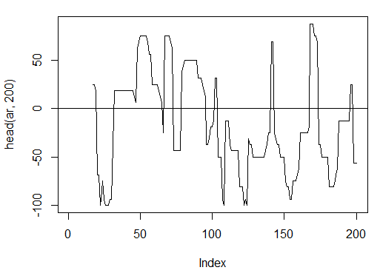
Fig. 14. Indicator aroon(HL, n)
图14 aroon指标（HL,n）
> summary(ar)
Min. 1st Qu. Median Mean 3rd Qu. Max. NA's
-100.00 -56.25 -18.75 -7.67 43.75 100.00 16
3.3.2.3. Commodity Channel Index - CCI(HLC, n) - 1 out CCI(HLC,n) – 1个输出值
> cci<-CCI(price[ ,2:4], n = 16)
> plot.ts(head(cci, 200))
> abline(h = 0)
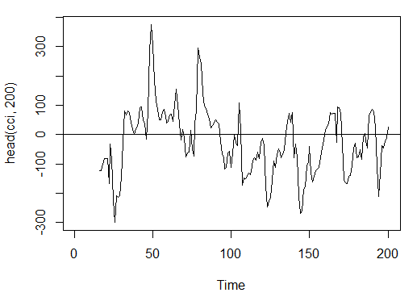
Fig. 15. Indicator Commodity Channel Index - CCI(HLC, n)
图15 CCI指标 – CCI(HLC,n)
> summary(cci)
Min. 1st Qu. Median Mean 3rd Qu. Max. NA's
-469.10 -90.95 -18.74 -14.03 66.91 388.20 15
3.3.2.4. Chaikin Volatility - chaikinVolatility (HLC, n) - 1 out 蔡金波动率 chaikinVolatility(HLC, n)
> chv<-chaikinVolatility(price[ , 2:4], n = 16)
> summary(chv)
Min. 1st Qu. Median Mean 3rd Qu. Max. NA's
-0.67570 -0.29940 0.02085 0.12890 0.41580 5.15700 31
> plot(head(chv, 200), t = "l")
> abline(h = 0)
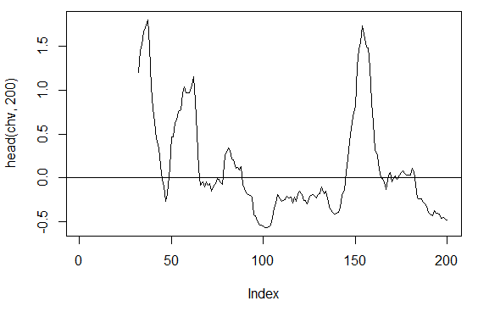
Fig. 16. Indicator chaikinVolatility (HLC, n)
蔡金波动率指标(HLC, n)
3.3.2.5. Chande Momentum Oscillator - CMO(Med, n) - 1 out CMO指标(Med, n) – 一个输出值
> cmo<-CMO(price[ ,'Med'], n = 16)
> plot(head(cmo, 200), t = "l")
> abline(h = 0)
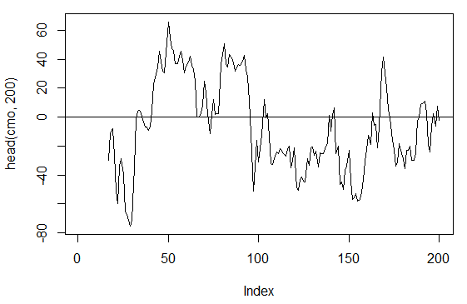
Fig. 17. Indicator Chande Momentum Oscillator - CMO(Med, n)
图17 CMO指标(Med, n)
> summary(cmo)
Min. 1st Qu. Median Mean 3rd Qu. Max. NA's
-97.670 -32.650 -5.400 -6.075 19.530 93.080 16

3.3.2.6. MACD oscillator - MACD(Med, nFast, nSlow, nSig) 1 out is used (macd) MACD(Med, nFast, nSlow, nSig) 1 个输出值(macd)
> macd<-MACD(price[ ,'Med'], 12, 26, 9)[ ,'macd']
> plot(head(macd, 200), t = "l")
> abline(h = 0)
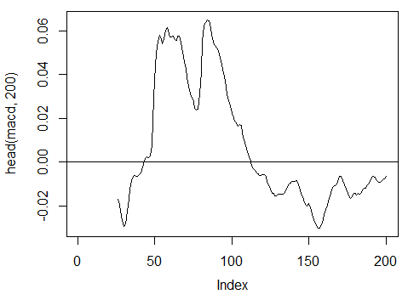
Fig. 18. Indicator MACD oscillator
图18 MACD震荡指标
> summary(macd)
Min. 1st Qu. Median Mean 3rd Qu. Max. NA's
-0.346900 -0.025150 -0.005716 -0.011370 0.013790 0.088880 25
3.3.2.7. OsMA(Med,nFast, nSlow, nSig) – 1 out OsMA(Med,nFast, nSlow, nSig) – 1 输出值
> osma<-macd - MACD(price[ ,'Med'],12, 26, 9)[ ,'signal']
> plot(head(osma, 200), t = "l")
> abline(h = 0)
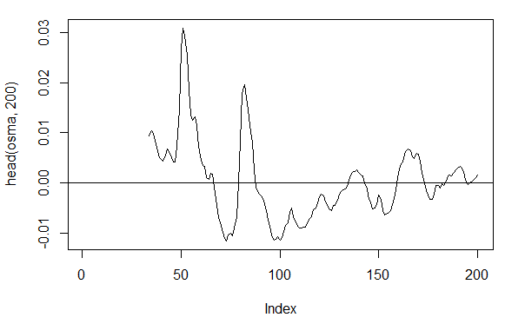
Fig. 19. Indicator OsMA(Med,nFast, nSlow, nSig)
图19 OsMA指标(Med, nFast, nSlow, nSig)
> summary(osma)
Min. 1st Qu. Median Mean 3rd Qu. Max. NA's
-0.10560 -0.00526 0.00034 0.00007 0.00646 0.05922 33
3.3.2.8. Relative Strength Index - RSI(Med,n) – 1 out RSI(Med,n) – 1输出值
> rsi<-RSI(price[ ,'Med'], n = 16)
> plot(head(rsi, 200), t = "l")
> abline(h = 50)
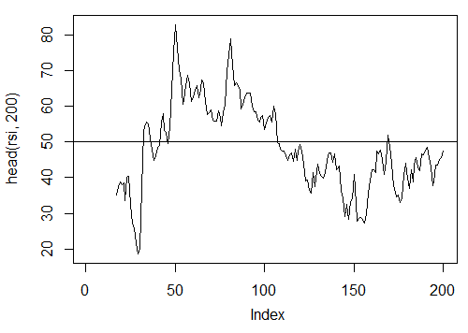
Fig. 20. Indicator Relative Strength Index - RSI(Med,n)
图20 RSI指标
> summary(rsi)
Min. 1st Qu. Median Mean 3rd Qu. Max. NA's
5.32 37.33 47.15 46.53 55.71 84.82 16
3.3.2.9. Stochastic Oscillator - stoch(HLC, nFastK=14, nFastD=3, nSlowD=3) - 3 out 随即震荡指标- stoch(HLC, nFastK=14, nFastD=3, nSlowD=3) - 3 输出值
> stoh<-stoch(price[ ,2:4], 14, 3, 3)
> plot.ts(head(stoh, 200))
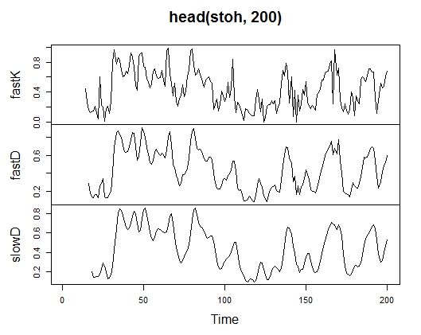
Fig. 21. Indicator Stochastic Oscillator - stoch(HLC, nFastK=14, nFastD=3, nSlowD=3)
图21 随机震荡指标 – stoch(HLC, nFastK=14, nFastD=3, nSlowD=3)
> summary(stoh)
fastK fastD slowD
Min. :0.0000 Min. :0.01782 Min. :0.02388
1st Qu.:0.2250 1st Qu.:0.23948 1st Qu.:0.24873
Median :0.4450 Median :0.44205 Median :0.44113
Mean :0.4622 Mean :0.46212 Mean :0.46207
3rd Qu.:0.6842 3rd Qu.:0.67088 3rd Qu.:0.66709
Max. :1.0000 Max. :0.99074 Max. :0.97626
NA's :13 NA's :15 NA's :17

3.3.2.10. Stochastic Momentum Index - SMI(HLC, n = 13, nFast = 2, nSlow = 25, nSig = 9) — 2 out 随机动能指数 – SMI(HLC, n = 13, nFast = 2, nSlow = 25, nSig = 9) — 2 输出值
> smi<-SMI(price[ ,2:4],n = 13, nFast = 2, nSlow = 25, nSig = 9)
> plot.ts(head(smi, 200))
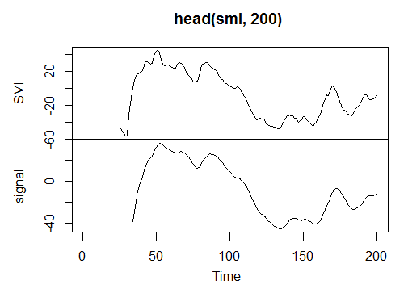
Fig. 22. Indicator Stochastic Momentum Index - SMI(HLC, n = 13, nFast = 2, nSlow = 25, nSig = 9)
图22 随机动能指数 – SMI(HLC, n = 13, nFast = 2, nSlow = 25, nSig = 9)
> summary(smi)
SMI signal
Min. :-82.185 Min. :-78.470
1st Qu.:-33.392 1st Qu.:-31.307
Median : -9.320 Median : -8.839
Mean : -8.942 Mean : -8.985
3rd Qu.: 15.664 3rd Qu.: 14.069
Max. : 71.878 Max. : 63.865
NA's :25 NA's :33
3.3.2.11. Volatility (Yang and Zhang) - volatility(OHLC, n, calc="yang.zhang", N=96)- 1 out 波动率(OHLC, n, calc="yang.zhang", N=96)- 1 输出值
> vol<-volatility(price[ ,1:4],n = 16,calc = "yang.zhang", N =96)
> plot.ts(head(vol, 200))
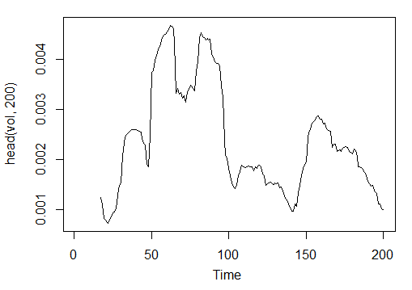
Fig. 23. Indicator Volatility (Yang and Zhang) - volatility(OHLC, n, calc="yang.zhang", N=96)
图23 波动率指标（Yang 和 Zhang）- volatility(OHLC, n, calc="yang.zhang", N=96)
> summary(vol)
Min. 1st Qu. Median Mean 3rd Qu. Max. NA's
0.000599 0.001858 0.002638 0.003127 0.004015 0.012840 16
So we have 17 variables from 11 indicators for EURUSD on the M15 timeframe for the OHLC sample 4000 bars deep.
这里我们有了EURUSD在15分钟图上的4000根K线的OHLC数据，用他们计算了11个指标的17个变量。
Use them to form a matrix and write the above parameters in one function with one formal parameter р, which will be required for optimization.
同它们来组成一个矩阵，然后将上述函数的参数合成一个需要优化的参数p
Calculate the matrix of the input parameters using the formula:
输入参数矩阵的计算使用如下公式：
In<-function(p = 16) {
adx<-ADX(price, n = p);
ar<-aroon(price[ ,c('High', 'Low')], n=p)[ ,'oscillator'];
cci<-CCI(price[ ,2:4], n = p);
chv<-chaikinVolatility(price[ ,2:4], n = p);
cmo<-CMO(price[ ,'Med'], n = p);
macd<-MACD(price[ ,'Med'], 12, 26, 9)[ ,'macd'];
osma<-macd - MACD(price[ ,'Med'],12, 26, 9)[ ,'signal'];
rsi<-RSI(price[ ,'Med'], n = p);
stoh<-stoch(price[ ,2:4],14, 3, 3);
smi<-SMI(price[ ,2:4],n = p, nFast = 2, nSlow = 25, nSig = 9);
vol<-volatility(price[ ,1:4],n = p,calc="yang.zhang", N=96);
In<-cbind(adx, ar, cci, chv, cmo, macd, osma, rsi, stoh, smi, vol);
return(In)
}
> X<-In()
> tail(X)
DIp DIn DX ADX ar cci chv
[3995,] 46.49620 36.32411 12.28212 18.17544 25.0 168.0407 0.1835102
[3996,] 52.99009 31.61164 25.26952 18.61882 37.5 227.7030 0.3189822
[3997,] 58.11948 28.16241 34.72000 19.62515 37.5 145.2337 0.3448520
[3998,] 56.00323 30.48687 29.50206 20.24245 37.5 118.5831 0.3068059
[3999,] 55.96197 28.78737 32.06467 20.98134 37.5 116.5376 0.3517668
[4000,] 54.97777 26.85440 34.36713 21.81795 62.5 160.0767 0.6169701
cmo macd osma rsi fastK
[3995,] 29.71342 -0.020870825 0.01666593 52.91932 0.8832685
[3996,] 41.89526 -0.009654368 0.02230591 61.49793 0.8833819
[3997,] 30.98237 -0.002051532 0.02392699 58.94513 0.7259475
[3998,] 33.84813 0.003454534 0.02354645 58.00549 0.7930029
[3999,] 38.84892 0.009590136 0.02374564 60.63806 0.8367347
[4000,] 54.71698 0.019303110 0.02676689 66.64815 0.9354120
fastD slowD SMI signal vol
[3995,] 0.7773581 0.7735064 -35.095406 -47.27712 0.003643196
[3996,] 0.7691688 0.7761507 -26.482951 -43.11828 0.003858942
[3997,] 0.8308660 0.7924643 -19.699762 -38.43458 0.003920541
[3998,] 0.8007775 0.8002707 -13.141932 -33.37605 0.003916109
[3999,] 0.7852284 0.8056239 -6.569699 -28.01478 0.003999789
[4000,] 0.8550499 0.8136852 2.197810 -21.97226 0.004293766
Raw input data are prepared. 原始输入数据准备结束。
3.3.3. Output Data (Target) 输出数据（目标）
Now we are going to form output (target data). As we mentioned before, we are going to use ZigZag.
现在我们要形式输出（目标数据）。正如我们之前所提到的，我们要用ZigZag指标。
We are going to use ZigZag with the channel width of 37 large points. ZigZag is going to be calculated by the average price. The indicator can be calculate by the HL prices, however the average price is preferable as the indicator is more stable in this case. Having extracted the signal (0 - Buy, 1 -Sell), convert it into an input matrix, which assumes the network model.
我们将使用37大点的通道宽度的ZigZag。ZigZag将被平均价格计算。该指标可以由HL的价格计算，但平均价格是最好的指标，在这种情况下更稳定。提取的信号（0买，1卖），将它转换成一个输入矩阵，假设网络模型。
Write a function:
写一个函数：
Out<-function(ch=0.0037){
# ZigZag has values on each bar and not only in the points
zz<-ZigZag(price[ ,'Med'], change = ch, percent = F, retrace = F, lastExtreme = T);
n<-1:length(zz);
# On the last bars substitute the undefined values for the last known ones
for(i in n) { if(is.na(zz[i])) zz[i] = zz[i-1];}
#Define the speed of ZigZag changes and move one bar forward
dz<-c(diff(zz), NA);
#If the speed >0 - signal = 0(Buy), if <0, signal = 1 (Sell) otherwise NA
sig<-ifelse(dz>0, 0, ifelse(dz<0, 1, NA));
return(sig);
}
Calculate signals. 计算信号。
> Y<-Out()
> table(Y)
Y
0 1
1567 2423
Class ratio is unbalanced. Number of examples of one class is greater than the other one. All models of the classification are unfriendly towards such sets.
类的比例是不平衡的。对一个类的实例的数量大于另一个。所有分类模型对这样的设置是不友好的。
When separating data into training and test samples, we will rectify this situation.
当把数据分离为训练和测试样本，我们将纠正这种情况。
3.3.4. Clearing Data数据清洗
Clear our data sets from undefined data. Clearing in this case implies a wider round of tasks. It includes clearing "virtually zero variables" and high correlated ones as well as some other tasks we are not going to discuss here.
从未定义数据中明确我们的数据集。在这种情况下，结算意味着更广泛的一轮任务。包括结算“几乎为0的变量”和高相关度变量和其他一些我们这里并不打算讨论的任务。
Write a function and clear the data写一个函数来清洗数据
Clearing<-function(x, y){
dt<-cbind(x,y);
n<-ncol(dt)
dt<-na.omit(dt)
return(dt);
}
> dt<-Clearing(X,Y); nrow(dt)
[1] 3957
The matrix has become 43 bars shorter.
矩阵变得缩短了43根K线。
3.3.5. Training and Testing Sample Formation训练和测试样本的形成
There are several ways of breaking the source data into the training and test samples. We are going to employ regular random division of the source data into the train and test one in proportion 8/10. It is important that the samples are stratified, which means that the ratio of the class instances in train and test samples must correspond to the class ratio in the source data set. It would also be beneficial to rectify class inequality in the source data set. There are two ways of doing it - either leveling by the greater or by the smaller class. As we require more examples, we are going to level by the greater class "1". In this case we are going to use the "caret" package.
有几种方法将源数据分解成的训练和测试样本。我们将采用将常规随机源数据导入到训练和在一个8/10的比例中测试。样品分层是很重要的,这意味着训练中的类实例和在测试样本的比例必须对应于源数据集中类的比率。它也将有利于纠正在源数据集的类不平等。这样做有两种方法——水平放在的更大或更小的类。我们需要更多的例子,我们要更大级别的类“1”。在本例中,我们将使用“caret”包。
Let us form a new balanced set where the number of instances of both classes are the same and are equal to the greater one.
让我们来自一个新的余额组，它的两个类的实例数量相同，并且等于更大那个。
3.3.6. Class Balancing平衡类
Below is the function that levels the number of classes by the greater side (if the divergence is greater than 15%) and returns a balanced matrix
下面是一个函数，它取更大一边对类数量分级（如果离散度大于15%）然后返回一个余额矩阵。
Balancing<-function(DT) {
#Calculate a table with a number of classes
cl<-table(DT[ ,ncol(DT)]);
#If the divergence is less than 15%, return the initial matrix
if(max(cl)/min(cl)<= 1.15) return(DT)
#Otherwise level by the greater side
DT<-if(max(cl)/min(cl)> 1.15) { # 得到和最大数量相同数量对手的样本
upSample(x = DT[ ,-ncol(DT)],y = as.factor(DT[ , ncol(DT)]), yname = "Y")
}
#Convert Y (factor) into a number
DT$Y<-as.numeric(DT$Y)
#Recode Y from 1,2 into 0,1
DT$Y<-ifelse(DT$Y == 1, 0, 1)
#Convert dataframe to matrix
DT<-as.matrix(DT)
return(DT);
}
Explanation. In the first string calculate the number of instances of each class (vector, with the dimension equal to the number of classes).
解释。第一个字符串计算每一类的实例数（向量，与维度相等的类的数量）。
Find the ratio of the greater vector to the smaller one and if it is less than the set threshold one, exit. If the ratio is greater, then calculate the function, having put in x and y separately. Y must be previously converted into a factor.
找到大小向量的比值，如果小于组阀值，退出。如果比值更大，计算函数，分别带入x和y。你必须预先转换Y为因子。
This is the requirement to the formal parameters of the upSample() function. Since we do not need the target variable as a factor, we convert it back into a numeric one with values 0 and 1. Please note that when we convert a numeric variable (0,1) into a factor, we receive text variables "0" and "1". At the reversed conversion into numeric variables, we get 1 and 2 (!). We replace them with 0 and 1. Our data set gets converted from the "data frame" to the class "matrix". Calculate it:
这是对upSample()函数的形式参数的要求。因为我们不需要目标变量为一个因子，我们需要把它变成一个值为0和1的数字之一。请注意，当我们把一个数值变量（0,1）为因子，我们就会接收文本变量“0”和“1”。在反向转换为数值变量，我们得到了1和2（！）。我们用0和1替换他们。我们的数据集从“数据结构”转换 “矩阵”类。计算：
dt.b<-Balancing(dt)
x<-dt.b[ ,-ncol(dt.b)]
y<-dt.b[ , ncol(dt.b)]
This way we have the source dt data set (input and output) and the balanced set dt.b.
这样我们就得到了源数据组dt（输入和输出）和余额组dt.b。
Divide it into the train and test samples
把它分为训练和测试样本
Obtain the indices of the train and test samples from the "rminer" package using the holdout() function.
使用”rminer”包中的holdout()函数，获得训练用的指标和测试样本。
> library('rminer')
> t<-holdout(y, ratio = 8/10, mode = "random")
The t object is a list containing indices of the training (t$tr) and the test (t$ts) data set. The received sets are stratified.
t对象是一个包含训练指标(t$tr)和测试数据组(t$ts)的列表。接收组被分层。
3.3.7. Preprocessing预处理
Our input data source contains variables with different value ranges. Essentially, deep networks are regular networks with a peculiar way of initializing weights.
我们的输入数据源包含不同取值范围的变量。本质上说，深度网络是一个以独特方式初始化权重的规则网络。
Neural networks can receive the input variables in the range (-1; 1) or (0, 1). Normalize the input variables into the range of [-1, 1].
神经网络可以接收(-1,1)或者(0,1)范围的输入变量。然后规范输入变量为[-1,1]。
For that use the preProcess() function from the "caret" package. Please note that the parameters of preprocessing are to be calculated on the training data set and save them for further preprocessing of the test data set and newly input data.
规范输入变量需要使用”caret”包中的preProcess()函数。请注意预处理参数会在训练数据集被计算并为了将来的测试数据集和新的输入数据的预处理进行保存。
> spSign<-preProcess(x[t$tr, ], method = "spatialSign")
> x.tr<-predict(spSign, x[t$tr, ])
> x.ts<-predict(spSign, x[t$ts, ])
Now we have everything for building, training and testing a deep neural network.
现在我们有了可以构建，训练和测试深度神经网络的一切。
3.4. Building, Training and Testing Models构建，训练和测试模型
We are going to build and train the DN SAE model. The formula of the model and description of the variables:
我们要建立和训练DN SAE模型。模型的公式和变量描述如下：
sae.dnn.train(x, y, hidden = c(10), activationfun = "sigm", learningrate = 0.8, momentum = 0.5, learningrate_scale = 1, output = "sigm", sae_output = "linear", numepochs = 3, batchsize = 100, hidden_dropout = 0, visible_dropout = 0)
where: 变量描述：
- x is a matrix of input data;
x是输入数据矩阵；
- y is a vector or matrix of target variables;
y是向量或目标变量的矩阵；
- hidden is a vector with a number of neurons in every hidden layer. By default c(10);
hidden是每个隐层神经元数量的向量。默认c(10)；
- activationfun is a function of activating hidden neurons. Can be "sigm", "linear", "tanh". By default "sigm";
activationfun是激活隐藏神经元的函数。可以是“sigm”，“linear”，“tanh”。默认“sigm”；
- learningrate is a training level for the gradient descent. By default = 0.8;
learningrate是梯度下降的训练水平。默认0.8；
- momentum is a momentum for the gradient descent. By default = 0.5;
momentum是梯度下降的动量。默认0.5；
- learningrate_scale training level can be multiplied by this value after every iteration. By default =1.0; learningrate_scale每次迭代之后训练水平可以乘以这个值。默认1.0；
- numepochs is a number of iterations for training. By default =3;
numepochs是训练迭代次数。默认3；
- batchsize is the size of small amount of data being trained. By default =100;
batchsize是被训练的小量数据的大小。默认100；
- output is the activation function for output neurons can be "sigm", "linear", "softmax". By default "sigm";
output是输出神经元的激活函数，可以是“sigm”，“linear”，“softmax”。默认“sigm”；
- sae_output is the activation function of output neurons of SAE, can be "sigm", "linear", "softmax". By default "linear";
sae_output是SAE输出神经元的激活函数，可以是“sigm”，“linear”，“softmax”。默认“linear“;
- hidden_dropout is a deletable part for hidden layers. By default =0;
hidden_dropout是隐层的可删除的部分。默认0；
- visible_dropout is a deletable part of the visible (input) layer. By default =0.
visible_dropout是可见（输入）层的可删除部分。默认= 0。
We are going to create a model with the following dimensions (17, 100, 100, 100, 1), train it, note the time of learning and observe the forecast.
我们要用下面的维度创建模型（17，100，100，100，1），训练它，注意学习的时间，观察预测。
> system.time(SAE<-sae.dnn.train(x= x.tr, y= y[t$tr], hidden=c(100,100,100), activationfun = "tanh", learningrate = 0.6, momentum = 0.5, learningrate_scale = 1.0, output = "sigm", sae_output = "linear", numepochs = 10, batchsize = 100, hidden_dropout = 0, visible_dropout = 0))
begin to train sae ......
training layer 1 autoencoder ...
training layer 2 autoencoder ...
training layer 3 autoencoder ...
sae has been trained.
begin to train deep nn ......
deep nn has been trained.
user system elapsed
12.92 0.00 13.09
As we can see, it happens in two stages. At first autoencoder gets trained layer by layer and then the neural network.
我们可以看到，它发生了两个阶段。首先自编码得到逐层训练，然后是神经网络。
The small number of training times and immense number of hidden neurons in the three layers were set on purpose. The whole process took 13 seconds!
按照需求，训练次数设置很小，而三层隐藏神经元却有很大的数字。整个过程花了13秒！
Let us evaluate forecasts on the test set of predictors.
让我们对预测测试集进行评估。
> pr.sae<-nn.predict(SAE, x.ts)
> summary(pr.sae)
V1
Min. :0.2649
1st Qu.:0.2649
Median :0.5881
Mean :0.5116
3rd Qu.:0.7410
Max. :0.7410
Convert into the levels 0,1 and calculate measurements
转换到等级0,1然后计算测量
> pr<-ifelse(pr.sae>mean(pr.sae), 1, 0)
> confusionMatrix(y[t$ts], pr)
Confusion Matrix and Statistics

Reference
Prediction 0 1
0 316 128
1 134 378

Accuracy : 0.7259
95% CI : (0.6965, 0.754)
No Information Rate : 0.5293
P-Value [Acc > NIR] : <2e-16

Kappa : 0.4496
Mcnemar's Test P-Value : 0.7574

Sensitivity : 0.7022
Specificity : 0.7470
Pos Pred Value : 0.7117
Neg Pred Value : 0.7383
Prevalence : 0.4707
Detection Rate : 0.3305
Detection Prevalence : 0.4644
Balanced Accuracy : 0.7246

'Positive' Class : 0
This is not an outstanding coefficient. We are more interested in the profit that we are going to make using these signals, not the coefficient. Check it on the last 500 bars (approximately a week). We are going to receive signals on the last 500 sequential bars from our trained network.
这并非优秀的系数。我们更感兴趣的是使用这些信号得到的利润，而不是系数。检查它最后500根K线(大约一星期)。我们将要接收我们训练的网络中最后500个连续K线的信号。
Normalize the last 500 bars of input data, receive forecasts from the trained neural network and convert them into signals -1= (Sell) and 1 = (Buy)
规范输入数据中最后500根K线，接收训练后的神经网络预测，并转换为信号：-1 = (做空)，1 = (做多)
> new.x<-predict(spSign,tail(dt[ ,-ncol(dt)], 500))
> pr.sae1<-nn.predict(SAE, new.x)
> pr.sig<-ifelse(pr.sae1>mean(pr.sae1), -1, 1)
> table(pr.sig)
pr.sig
-1 1
235 265
> new.y<-ifelse(tail(dt[ , ncol(dt)], 500) == 0, 1, -1)
> table(new.y)
new.y
-1 1
201 299
> cm1<-confusionMatrix(new.y, pr.sig)
> cm1
Confusion Matrix and Statistics

Reference
Prediction -1 1
-1 160 41
1 75 224

Accuracy : 0.768
95% CI : (0.7285, 0.8043)
No Information Rate : 0.53
P-Value [Acc > NIR] : < 2.2e-16

Kappa : 0.5305
Mcnemar's Test P-Value : 0.002184

Sensitivity : 0.6809
Specificity : 0.8453
Pos Pred Value : 0.7960
Neg Pred Value : 0.7492
Prevalence : 0.4700
Detection Rate : 0.3200
Detection Prevalence : 0.4020
Balanced Accuracy : 0.7631

'Positive' Class : -1
The Accuracy coefficient is not bad, though we are more interested in the profit, not the coefficient.
精度系数还不错，虽然我们更感兴趣的是利润，而不是系数。
Test the profit for the last 500 bars using our predicted signals and get the balance curve:
使用我们的预测信号来测试最后500根K线的收益，得到余额曲线：
> bal<-cumsum(tail(price[ , 'CO'], 500) * pr.sig)
> plot(bal, t = "l")
> abline(h = 0)
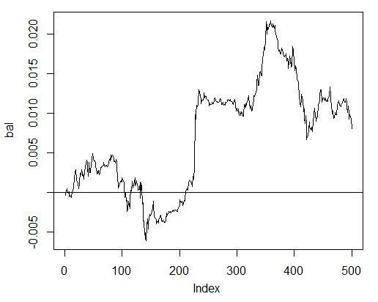
Fig. 24. Balance on the last 500 bars by the neural network signals
图24 神经网络信号作用在最后500根K线上的余额曲线
The balance was calculated without taking into consideration spread, slippage and other realities of a live market.
此余额没有考虑点差，滑点和其他现实市场的活动。
Now compare with the balance that would have been obtained from the ideal signals of ZZ. The red line is the balance by the neural network signals:
现在对比理想信号ZigZag。红线是神经网络信号影响后的余额。
> bal.zz<-cumsum(tail(price[ , 'CO'], 500) * new.y)
> plot(bal.zz, t = "l")
> lines(bal, col = 2)
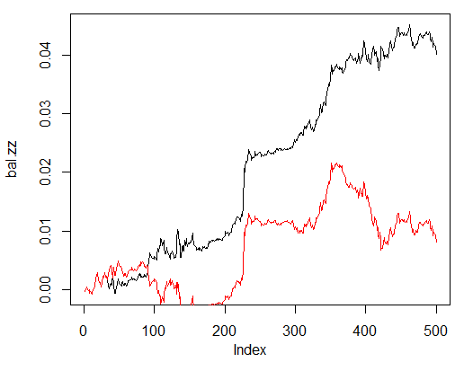
Fig. 25. Balance on the last 500 bars by the neural network signals and the ZigZag signals
图25神经网络和ZigZag信号作用在最后500根K线上的余额曲线[黑色为新线]
There is potential for improvement. 这里显示还有改进的空间。
Write two functions to facilitate two helper functions Estimation() and Testing(). The first will generate coefficients Accuracy/Err and the second one balance Bal/BalZZ.
编写2个函数促进辅助函数Estimation() 和 Testing()。第一个生成精度/错误系数，第二个生成余额比 Bal/BalZZ
It allows to obtain a result straight away changing some network parameters and see what parameters influence the quality of the network.
它可以立刻改变网络参数，得到了一个结果，看哪些参数影响网络质量。
Having written a fitness function, optimal network parameters can be found using evolutionary (genetic) algorithm without any disruptions for the trading process. We are not going to dedicate time to it in this article and will consider it in detail some other time.
写一个健身函数，优化网络参数，可以发现使用进化（遗传）的交易过程中没有任何中断算法。我们不会在这篇文章中话费更多时间来解释它，其他时候会做详解。
Below is the function Estimation() calculating coefficients Err/Accuracy:
下面是Estimation() 函数计算的错误/精度系数：
Estimation<-function(X, Y, r = 8/10, m = "random", norm = "spatialSign",
h = c(10), act = "tanh", LR = 0.8, Mom = 0.5,
out = "sigm", sae = "linear", Ep = 10, Bs = 50,
CM=F){
#Indices of the training and test data set
t<-holdout(Y, ratio = r, mode = m)
#Parameters of preprocessing
prepr<-preProcess(X[t$tr, ], method = norm)
#Divide into train and test data sets with preprocessing
x.tr<-predict(prepr, X[t$tr, ])
x.ts<-predict(prepr, X[t$ts, ])
y.tr<- Y[t$tr]; y.ts<- Y[t$ts]
#Train the model
SAE<-sae.dnn.train(x = x.tr , y = y.tr , hidden = h,
activationfun = act,
learningrate = LR, momentum = Mom,
output = out, sae_output = sae,
numepochs = Ep, batchsize = Bs)
#Obtain a forecast on the test data set
pr.sae<-nn.predict(SAE, x.ts)
#Recode it into signals 1,0
pr<-ifelse(pr.sae>mean(pr.sae), 1, 0)
#Calculate the Accuracy coefficient or classification error
if(CM) err<-unname(confusionMatrix(y.ts, pr)$overall[1])
if(!CM) err<-nn.test(SAE, x.ts, y.ts, mean(pr.sae))
return(err)
}
Formal parameters:
形式参数：
- X – matrix of input raw predictors;
X – 输入原预测矩阵；
- Y – vector of the target variable;
Y – 目标变量的向量；
- r – ratio train/test;
r – 训练/测试比；
- m – sample formation mode (random or consequent);
m – 样品形成模式（随机或顺序）；
- norm – mode of input parameters normalizing ([ -1, 1]= "spatialSign";[0, 1]="range");
norm – 输入参数规范的模式（[-1，1] =“spatialSign”；[0，1] =“range”）；
- h – vector with a number of neurons in the hidden layers;
h – 隐层神经元数量向量；
- act – activation function of hidden neurons;
act - 隐层神经元的激活函数;
- LR – training level;
LR – 训练水平；
- MOM — momentum;
MOM -动量；
- out – activation function of the output layer;
out - 输出层的激活函数；
- sae – activation function of the autoencoder;
sae – 自编码激活函数；
- Ep – number of the training epochs;
Ep –训练时代数量；
- Bs – size of the small sample;
Bs – 小样本的大小；
- CM– Boolean variable , if TRUE print Accuracy. Else Err.
CM – 布尔变量，如果为真则打印Accuracy精度。否则Err。
As an example we are going to calculate the classification error on the unbalanced data set dt by the network with three hidden layers each containing 30 neurons:
例如我们要在三个隐藏层每层包含30个神经元的网络上，计算不平衡数据集dt的分类错误。
> Err<-Estimation(X = dt[ ,-ncol(dt)], Y = dt[ ,ncol(dt)], h=c(30, 30, 30), LR= 0.7)
begin to train sae ......
training layer 1 autoencoder ...
training layer 2 autoencoder ...
training layer 3 autoencoder ...
sae has been trained.
begin to train deep nn ......
deep nn has been trained.
> Err
[1] 0.1376263
The function Testing() calculates balance by the forecast signals or by the ideal ones (ZigZag):
Testing()函数用预测信号，或者理想信号(ZigZag)来计算余额：
Testing<-function(dt1, dt2, r=8/10, m = "random", norm = "spatialSign",
h = c(10), act = "tanh", LR = 0.8, Mom = 0.5,
out = "sigm", sae = "linear", Ep = 10, Bs=50,
pr = T, bar = 500){
X<-dt1[ ,-ncol(dt1)]
Y<-dt1[ ,ncol(dt1)]
t<-holdout(Y, ratio = r, mode = m)
prepr<-preProcess(X[t$tr, ], method = norm)
x.tr<-predict(prepr, X[t$tr, ])
y.tr<- Y[t$tr];
SAE<-sae.dnn.train(x = x.tr , y = y.tr , hidden = h,
activationfun = act,
learningrate = LR, momentum = Mom,
output = out, sae_output = sae,
numepochs = Ep, batchsize = Bs)
X<-dt2[ ,-ncol(dt2)]
Y<-dt2[ ,ncol(dt2)]
x.ts<-predict(prepr, tail(X, bar))
y.ts<-tail(Y, bar)
pr.sae<-nn.predict(SAE, x.ts)
sig<-ifelse(pr.sae>mean(pr.sae), -1, 1)
sig.zz<-ifelse(y.ts == 0, 1,-1 )
bal<-cumsum(tail(price[ ,'CO'], bar) * sig)
bal.zz<-cumsum(tail(price[ ,'CO'], bar) * sig.zz)
if(pr) return(bal)
if(!pr) return(bal.zz)
}
Formal parameters:
形式参数：
- dt1 – matrix of the input and target variable used for training the network;
dt1 - 输入和目标变量矩阵，用于训练网络；
- dt2 - matrix of the input and target variables used for testing the network;
dt2 - 输入和目标变量矩阵，用于测试网络；
- pr – Boolean variable, if TRUE print the balance by the forecast signals, otherwise by ZigZag;
pr – 布尔变量，如果为真，打印由预测信号得到的余额，否则用ZigZag得到的余额；
- bar - the number of the last bars to use for calculating balance.
bar - 最后一根用于计算平衡的K线数字。
Calculate balance on the last 500 bars of our data set dt when training on the balanced data set dt.b by the neural network with the same parameters as above:
当神经网络对余额数据集dt.b训练时，用相同参数对数据集dt中最后500根K线进行计算。
> Bal<-Testing(dt.b, dt, h=c(30, 30, 30), LR= 0.7)
begin to train sae ......
training layer 1 autoencoder ...
training layer 2 autoencoder ...
training layer 3 autoencoder ...
sae has been trained.
begin to train deep nn ......
deep nn has been trained.
> plot(Bal, t = "l")
> abline(h = 0)
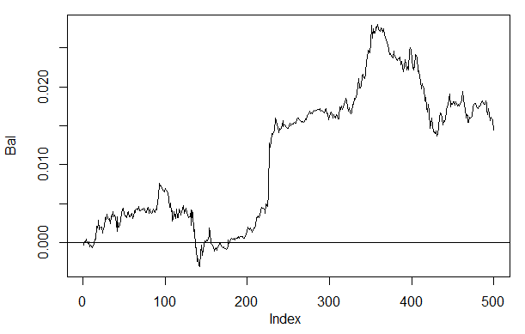
Fig. 26. Balance on the last 500 bars by the neural network signals h(30,30,30)
图26 神经网络信号h(30,30,30)作用在最后500根K线上的余额曲线
If we compare the result with the previously obtained balance then we can see a significant improvement. This is not the most interesting point here though.
如果我们将此结果与之前得到的余额作比较，我们可以看到显着的改善。这还不是本文中最有趣的一点。
If we take a look at the price plot on the last 500 bars, then we can see what parts of it were best accepted by our network (150-350 bars).
如果我们看一下最后的500根K线的价格图，我们就可以看到，它的一部分已经被我们的网络最好的接受了（在150-350根K线的区间）。
> plot(tail(price[ ,'Close'], 500), t = "l")
> abline(v = c(150,350), col=2)
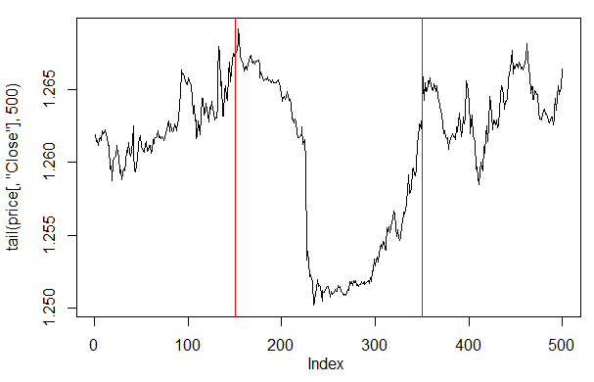
Fig. 27. Plot of the Close price on the last 500 bars
图27 收盘价在过去500根K线的情况
Note: When decoding the forecast outputs, we used a simplified version greater/less than the average, though other versions can be used.
注：当解码输出预测，我们使用一个简化版本的大于或小于平均值，但其他版本可以使用。
If the values are greater than 0.6 or less than 0.4, the unstable segment of 0.4-0.6 gets cut off. More precise class boundaries can be obtained at calibration. This is going to be discussed later.
如果该值大于0.6或小于0.4，0.4-0.6的不稳定段被切断。更精确的类边界可以校准。这将在之后讨论。
Our function Testing() is going to be changed a little if an additional parameter dec is going to be introduced. This will allow us to select a way to decode ("mean" or "60/40") and check on the predicted values what impact it is going to have on the balance.
函数Testing()将产生稍微的改变，如果一个额外的参数dec出现。这将使我们能够选择一种方式来解码（“平均”或“60 / 40”）检查预测值会对余额有什么样的影响。
Testing.1<-function(dt1, dt2, r = 8/10, m = "random", norm = "spatialSign",
h = c(10), act = "tanh", LR = 0.8, Mom = 0.5,
out = "sigm", sae = "linear", Ep = 10, Bs = 50,
pr = T, bar = 500, dec=1){
X<-dt1[ ,-ncol(dt1)]
Y<-dt1[ ,ncol(dt1)]
t<-holdout(Y, ratio = r, mode = m)
prepr<-preProcess(X[t$tr, ], method = norm)
x.tr<-predict(prepr, X[t$tr, ])
y.tr<- Y[t$tr];
SAE<-sae.dnn.train(x = x.tr , y = y.tr , hidden = h,
activationfun = act,
learningrate = LR, momentum = Mom,
output = out, sae_output = sae,
numepochs = Ep, batchsize = Bs)
X<-dt2[ ,-ncol(dt2)]
Y<-dt2[ ,ncol(dt2)]
x.ts<-predict(prepr, tail(X, bar))
y.ts<-tail(Y, bar)
pr.sae<-nn.predict(SAE, x.ts)
#Вариант +/- mean
if(dec == 1) sig<-ifelse(pr.sae>mean(pr.sae), -1, 1)
#Вариант 60/40
if(dec == 2) sig<-ifelse(pr.sae>0.6, -1, ifelse(pr.sae<0.4, 1, 0))
sig.zz<-ifelse(y.ts == 0, 1,-1 )
bal<-cumsum(tail(price[ ,'CO'], bar) * sig)
bal.zz<-cumsum(tail(price[ ,'CO'], bar) * sig.zz)
if(pr) return(bal)
if(!pr) return(bal.zz)
}
Calculate and assess the balance with the first and the second ways of decoding.
对解码的第一和第二方式进行余额的计算和评估。
In order the results to repeat, set pseudorandom number generator in the same position.
为了重复的结果，在相同的位置设置的伪随机数发生器。
> set.seed<-1245
> Bal1<-Testing.1(dt.b, dt, h = c(30, 30, 30), LR = 0.7, dec = 1)
begin to train sae ......
training layer 1 autoencoder ...
training layer 2 autoencoder ...
training layer 3 autoencoder ...
sae has been trained.
begin to train deep nn ......
deep nn has been trained.
> set.seed<-1245
> Bal2<-Testing.1(dt.b, dt, h = c(30, 30, 30), LR = 0.7, dec = 2)
begin to train sae ......
training layer 1 autoencoder ...
training layer 2 autoencoder ...
training layer 3 autoencoder ...
sae has been trained.
begin to train deep nn ......
deep nn has been trained.
> plot(Bal2, t = "l")
> lines(Bal1, col = 2)
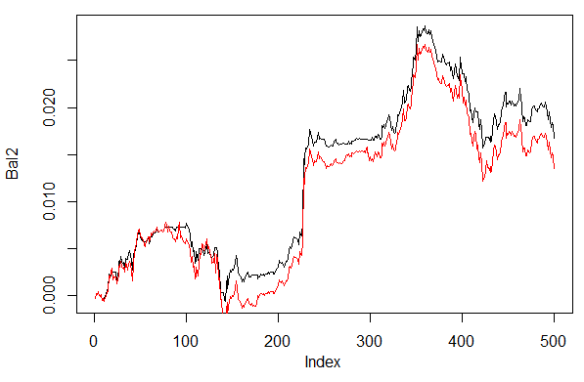
Fig. 28. Balance for the last 500 bars by the neural network signals with different ways of decoding forecasts
图28 500条K线经由具有不同解码方式的神经网络信号预测的余额
Clearly, balance by the second way 60/40 looks better. There is space for improvement in this aspect too.
显然，通过第二种方式60 / 40平衡看起来更好。在这方面还有改善的空间。
Here is the last thing to check. In theory, an ensemble of several neural networks gives a better and more stable result. We are going to test an ensemble consisting of several networks, which are trained on the same samples though they can be trained on independent samples. The result of the ensemble's forecast is a simple average of the forecasts of all the networks. There are other more complex ways of averaging.
进行检查的最后一项。理论上，一个多神经网络集成提供了一个更好、更稳定的结果。我们要测试的几个集成网络，他们被作为相同的样本被训练，尽管他们可以作为独立样本被训练。整体的结果，是一个对所有网络预测的简单平均。还有其他更复杂的平均方式。
We are going to improve our function Testing() by adding one more parameter — ans=1 specifying the number of the networks in the ensemble.
我们将通过添加一个或多个参数—— ans =1 指定集合中网络数量，来提高我们的Testing()函数。
3.4.1. Parallel Calculations并行计算
Since computations by several independent models can easily be paralleled, we are going to use the opportunity provided by the R language and create a cluster consisting of a several processor cores or computers of a local networks irrespective to what operating systems these computers have.
自从几个独立模型的计算可以通过并行简化，我们开始利用R语言提供的机会，创造一个由多处理器或者局域网络中无论装了什么操作系统的多个计算机的集群。
For that we need the "foreach" and the "doParallel" packages. Below is a very simple function that will launch a cluster for all the cores of our processor.
为此我们需要”foreach”和”doParallel”包。下面是一个非常简单的函数，它推出了包含所有核心处理器的集群。
library(doParallel)
library(foreach)
puskCluster<-function(){
cores<-detectCores()
cl<-makePSOCKcluster(cores)
registerDoParallel(cl)
clusterSetRNGStream(cl)
return(cl)
}
Several points are clarified below. In the first two strings we load necessary libraries. They need to be previously installed on your computer. Then we define how many cores there are in the processor, create a cluster, register a package for parallel computations, install an independent pseudorandom number generator in every stream of calculations and return the cluster handle. Quality of the pseudorandom number generator for computations of every model is extremely important though this is a separate topic.
以下几点是明确的。最初的两行字符串我们加载必要的库文件。他们需要的预先安装在您的计算机上。然后我们定义处理器有多少核心，创建一个集群，注册一个包用于并行计算，在计算每个流安装一个独立的伪随机数发生器，返回集群句柄。对于每一个模型计算的伪随机数发生器的质量极为重要，虽然那另外的主题。
After the cluster has been launched and all required computations have been made, we must remember to stop it:
在集群已经启动，所有需要的计算完成，我们必须记住去停止它：
cl<-puskCluster()
stopCluster(cl)
Parallel computations are going to be performed by the following formula from the "foreach" package:
并行计算是由下面“foreach”包中的公式完成：
SAE<-foreach(times(ans), .packages = "deepnet") %dopar%
sae.dnn.train(x = x.tr , y = y.tr , hidden = h,
activationfun = act,
learningrate = LR, momentum = Mom,
output = out, sae_output = sae,
numepochs = Ep, batchsize = Bs)
where times(ans) is a number of networks that we want to obtain and .packages points to the package to take the calculated function.
Times(ans)是我们要获知的网络数量，.packages指明了计算函数的包。
The result has a form of a list and contains the number of trained networks we need.
结果有一个列表的形式，包含了我们需要的训练网络的数量。
Then we require the forecast from every network and calculate the average.
然后我们需要对每个网络预测和计算平均值。
pr.sae<-(foreach(i = 1:ans, .combine = "+") %do% nn.predict(SAE[[i]], x.ts))/ans
Here i is a vector of the trained network indices,.combine="+" specifies what form the returned predicts in all neural networks are supposed to be returned in. In this case we required to return a sum and perform these computations sequentially, not in a parallel way (operator %do%). The obtained sum is going to be divided by the number of the neural networks and it will be the end result. This is nice and simple.
这里的i是一个训练过的网络指标矢量，.combine="+" 指明所有的神经网络预测中什么样的返回形式应该返回输入。在这种情况下，我们需要返回一个和，然后按顺序执行这些计算，不用并行方式(运算符%do%)。获得的和除以神经网络数量，这样就得到结果。非常简单有效。
Calculate balance obtained from ensembles consisting of 3 and 4 neural networks with the same parameters that the ones above and using the decoding way 60/40. Compare with the results on one neural network. To evaluate effectiveness of parallel computations, increase the number of epochs to 300 and time the process of obtaining the forecast.
对包括3和4组成，使用以上参数中的一个同时使用60/40解码模式的神经网络进行余额计算。在一个神经网络下对比结果。增加epchs到300，对预测进程进行计时，以此提高并行计算的有效性。
1. One neural network: 一个神经网络
> system.time(Bal21<-Testing.1(dt.b, dt, h = c(30, 30, 30), LR = 0.7, dec = 2, Ep=300))
begin to train sae ......
training layer 1 autoencoder ...
####loss on step 10000 is : 0.000057
####loss on step 20000 is : 0.000043
training layer 2 autoencoder ...
####loss on step 10000 is : 0.000081
####loss on step 20000 is : 0.000086
training layer 3 autoencoder ...
####loss on step 10000 is : 0.000072
####loss on step 20000 is : 0.000066
sae has been trained.
begin to train deep nn ......
####loss on step 10000 is : 0.069451
####loss on step 20000 is : 0.079629
deep nn has been trained.
user system elapsed
115.78 0.00 116.96
> plot(Bal21, t = "l")
> abline(h = 0)
2. Ensemble of 3 neural networks: 集成3个神经网络
> system.time(Bal41<-Testing.2(dt.b, dt, h = c(30, 30, 30), LR = 0.7, Ep=300, dec = 2, ans=3))
user system elapsed
0.22 0.06 233.64
> lines(Bal41, col=4)
3. Ensemble of 4 neural networks: 集成4个神经网络
> system.time(Bal44<-Testing.2(dt.b, dt, h = c(30, 30, 30), LR = 0.7, Ep=300, dec = 2, ans=4))
user system elapsed
0.13 0.03 247.86
> lines(Bal44, col=2)
Execution time at parallel computation is optimal if the number of streams is multiple to the number of cores. I have used 2 cores.
如果流的数量是核的数量的倍数，并行计算的执行时间是最佳的。我的是2核。
Saying that, there is no significant advantages in the balance. On the chart below, the blue plot denotes 3 networks, the red one - 4 networks and the black one - one network.
这么说吧，对于余额是没有明显优势的。下面图表中，蓝色线表示3个网络，红色表示4个网络，红线——4网络，黑线——单一网络。
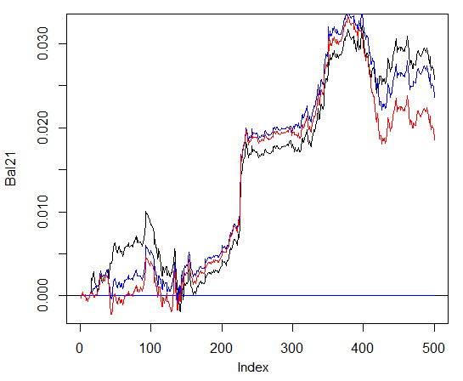
Fig. 29. Balance on the last 500 bars by the signals of the ensembles consisting of 3 and 4 neural networks and one network
图29 最后500根K线在3个、4个和单一网络信号下的余额曲线图
In general, the result depends on many parameters, starting from input and output data, the way of their normalizing, the number of hidden layers and the number of neurons in those layers, training level, the number of training epochs and many others.
一般来说，结果取决于许多参数，从输入和输出数据开始，其规范的方式，隐含层数和层神经元数量，训练水平，训练时代数等等。
Last three examples. Calculate balance on the last 1000 bars with three neural networks with different numbers of hidden neurons in three hidden layers.
最后三个例子。计算最后1000K线在3个神经网络下在3个隐藏层中使用不同数量隐藏神经元下的余额。
> system.time(Bal0<-Testing.1(dt.b, dt, h = c(30, 30, 30), LR = 0.7, dec = 2, Ep=300, bar=1000))
begin to train sae ......
training layer 1 autoencoder ...
####loss on step 10000 is : 0.000054
####loss on step 20000 is : 0.000044
training layer 2 autoencoder ...
####loss on step 10000 is : 0.000078
####loss on step 20000 is : 0.000079
training layer 3 autoencoder ...
####loss on step 10000 is : 0.000090
####loss on step 20000 is : 0.000072
sae has been trained.
begin to train deep nn ......
####loss on step 10000 is : 0.072633
####loss on step 20000 is : 0.057917
deep nn has been trained.
user system elapsed
116.09 0.02 116.26
> max(Bal0)
[1] 0.04725
> plot(Bal0, t="l")
> tail(Bal0,1)
[1] 0.03514
Maximum profit is 472 points, on the last bar 351 points. On the chart it is drawn in black.
利润最大值是472个点，最后一根是351个点。图表中用黑色表示。
> system.time(Bal0<-Testing.1(dt.b, dt, h = c(13, 8, 5), LR = 0.7, dec = 2, Ep=300, bar=1000))
begin to train sae ......
training layer 1 autoencoder ...
####loss on step 10000 is : 0.005217
####loss on step 20000 is : 0.004846
training layer 2 autoencoder ...
####loss on step 10000 is : 0.051324
####loss on step 20000 is : 0.046230
training layer 3 autoencoder ...
####loss on step 10000 is : 0.023292
####loss on step 20000 is : 0.026113
sae has been trained.
begin to train deep nn ......
####loss on step 10000 is : 0.057788
####loss on step 20000 is : 0.056932
deep nn has been trained.
user system elapsed
64.04 0.01 64.24
Warning message:
In sae$encoder[[i - 1]]$W[[1]] %*% t(train_x) + sae$encoder[[i - :
longer object length is not a multiple of shorter object length
> lines(Bal0, col="blue")
This is clearly an ineffective variation.
这显然是一个无效的变化。
The third variation: 第三个变种
> system.time(Bal0<-Testing.1(dt.b, dt, h = c(50, 50, 50), LR = 0.7, dec = 2, Ep=300, bar=1000))
begin to train sae ......
training layer 1 autoencoder ...
####loss on step 10000 is : 0.000018
####loss on step 20000 is : 0.000013
training layer 2 autoencoder ...
####loss on step 10000 is : 0.000062
####loss on step 20000 is : 0.000048
training layer 3 autoencoder ...
####loss on step 10000 is : 0.000053
####loss on step 20000 is : 0.000055
sae has been trained.
begin to train deep nn ......
####loss on step 10000 is : 0.096490
####loss on step 20000 is : 0.084860
deep nn has been trained.
user system elapsed
186.18 0.00 186.39
> lines(Bal0, col="red")
> max(Bal0)
[1] 0.0543
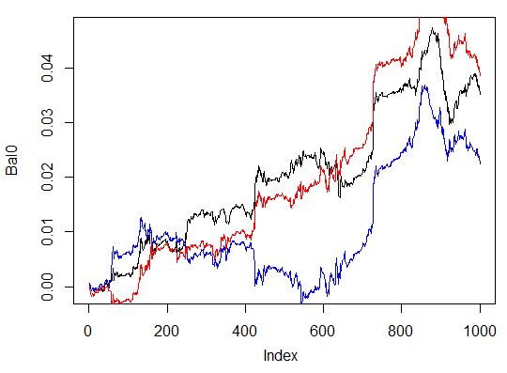
Fig. 30. Balance on the last 1000 bars by the signals of three neural networks with different numbers of hidden neurons
图30 三个神经网络，隐层神经元数不同的信号，在最后1000根K线下的余额
The results show that the third variant is the best out of the three with the maximum profit of 543 points. We only changed the number of hidden neurons and it led to a significant improvement. Searching of optimal parameters should be performed through evolutionary algorithms. This is up to the reader to explore.
结果表明，第三种得到最好的输出结果， 543个点的最大化利润。我们只改变隐藏层神经元的数目，它就带来了一个显着的改善。最优参数应通过进化算法进行搜索。这将由读者去自行探索。
It should be kept in mind that the author's algorithm has not been fully implemented in this package.
要注意的是，本文作者的算法在这个包中并没有完全实现。

4. The Implementation (Indicator and Expert Advisor) 实施（指标和EA）
Now we are going to write a program for the indicator and Expert Advisor using a deep network for receiving trading signals.
现在我们要为指标和EA写一个使用深网接收交易信号的程序。
There are two ways of such an implementation:
有两种方式实现：
The first one. Training of the neural network is performed in RStudio manually. After obtaining acceptable results, save the network in the appropriate catalog. Then launch the EA and indicator on the chart. The EA will load the trained network. The indicator prepares a vector of new input data on each new bar and passes it to the EA. The EA presents network data, receives a signal and then acts on it. The EA is carrying on with its usual activities such as opening and closing orders, trailing etc. The objective of the indicator is to prepare and pass on to the EA new input data on each new bar and, most importantly, present signals forecast by the network on a chart. Practice shows that visual control is the most efficient way of assessing a neural network.
第一种：神经网络的训练是在RStudio手动执行。获得可接受的结果后，在适当的目录保存网络。然后启动EA和指标图表。EA将训练好的网络。指示准备好每个新输入的每根K线数据向量，并传递到EA。EA提出了网络数据，接收信号，然后对它进行操作。EA继续平常的活动，例如打开和关闭订单，跟踪止损等。指标的目的是准备和传递到EA每一个新的K线输入数据，最重要的是，在图表上展现网络的信号预测。实践表明，视觉控制是评价神经网络的最有效的方法。
Second way. Launch the EA and the indicator on the chart. At the first launch, the indicator passes on to the EA a prepared large set of input and output data. The EA launches training, testing and selecting the best neural network. After that work goes on like in the first way.
第二种：在图标上运行EA和指标。在第一次运行时，该指标传递给EA准备好的大量输入和输出数据。EA运行训练，测试和选择最佳的神经网络。之后的工作如同在第一种方式。
We are going to write the link indicator-EA following the first algorithm. EA with a minimum of bows and frills.
我们按照第一种算法写的指标和EA链接器。EA最小量的修饰。
Why is it so difficult? This way of implementation allows to connect several indicators placed on different symbols/timeframes to one EA and work with them consequently. For that, the EA has to go through a little modernization. We are going to talk about it later.
为什么这么难？这种实现方式允许连接一个EA和在不同的商品/时图的几个指标，并与他们一起工作。为此，EA已经实现一个小小的现代化。我们要谈论它。
Below is the structure of interaction between the indicator and the EA:
下面是指标和EA之间的互动结构：
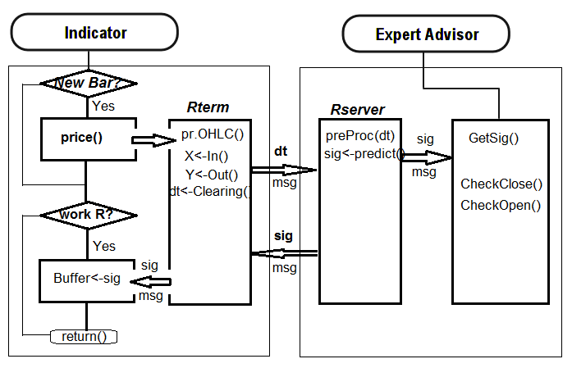
Fig. 31. Structure of interaction between the indicator and the EA
图31指标和EA之间的互动结构
4.1. Training and Saving the Model训练和节能模式
Using the indicator placed on the chart of our interest, obtain the necessary source data. For that, place the indicator on the chart, having set an input variable send=false, i.e. the visual representation is not supposed to get sent to the server. At the first launch on this symbol or timeframe, the indicator is to create the following directories /Symbol/TF/Test_Data/ in the data file of the terminal (/MQL4/Files).
在我们感兴趣的图表上放置指标，获取必要的数据源。为此，在图表上放置指标，设置一个输入变量 send = false, 即视觉表现不应该被发送到服务器。在第一次在此商品或时图运行时，指标会在终端数据文件文件夹(/MQL4/Files)下方,创建/Symbol/TF/Test_Data/目录。
Such an organization of directories gives an opportunity not to put experiment results together at preliminary training of models and not overwrite old data with new ones. Intermediary results will be stored in the /Symbol/TF/Test_Data/ directory and the model the EA is going to use for work will be located in /Symbol/TF/ (it will have to be placed there manually). The same result will be at the first launch on a new symbol or the EA's timeframe.
这样目录结构提供了一个便利，不把实验结果同模型的初步训练放在一起，也防止用新的数据覆盖旧的。中间结果将被存储在/Symbol/TF/Test_Data/目录，模型的EA是使用位于/Symbol/TF/（必须手动才能被放置）。相同的结果，将在第一次运行了一个新商品或EA的时图。
So, for EURUSD, M30, there are 4000 bars on 14.10.2014. We require the dt[] dataframe.
因此，对EURUSD，М30，在2014年10月14日有4000根K线记录。我们需要dt[]数据帧。
Balance classes: 平衡类：
> dt.b<-Balancing(dt)
> table(dt.b[ ,ncol(dt.b)])
0 1
2288 2288
Now, with the previously written function Testing.1(), train the deep neural network with 500 and 300 epochs and assess the balance obtained on the last 500 bars by the signals forecast by the neural network.
现在，与以前写的函数Testing.1()，培养深层神经网络500和300期评估最后500小节的信号由神经网络预测得到余额。
> system.time(bal<-Testing.1(dt.b, dt, h = c(50, 50, 50), LR = 0.7, dec = 2, Ep=500, bar=500))
begin to train sae ......
training layer 1 autoencoder ...
####loss on step 10000 is : 0.000017
####loss on step 20000 is : 0.000015
####loss on step 30000 is : 0.000015
training layer 2 autoencoder ...
####loss on step 10000 is : 0.000044
####loss on step 20000 is : 0.000041
####loss on step 30000 is : 0.000039
training layer 3 autoencoder ...
####loss on step 10000 is : 0.000042
####loss on step 20000 is : 0.000042
####loss on step 30000 is : 0.000036
sae has been trained.
begin to train deep nn ......
####loss on step 10000 is : 0.089417
####loss on step 20000 is : 0.043276
####loss on step 30000 is : 0.069399
deep nn has been trained.
user system elapsed
267.59 0.08 269.37
> plot(bal, t="l")
Save the neural network under a different name and train another one
把神经网络保存为一个不同的名称，然后训练另一个
> SAE1<-SAE
> system.time(bal<-Testing.1(dt.b, dt, h = c(50, 50, 50), LR = 0.7, dec = 2, Ep=300, bar=500))
begin to train sae ......
training layer 1 autoencoder ...
####loss on step 10000 is : 0.000020
####loss on step 20000 is : 0.000016
training layer 2 autoencoder ...
####loss on step 10000 is : 0.000050
####loss on step 20000 is : 0.000050
training layer 3 autoencoder ...
####loss on step 10000 is : 0.000051
####loss on step 20000 is : 0.000043
sae has been trained.
begin to train deep nn ......
####loss on step 10000 is : 0.083888
####loss on step 20000 is : 0.083941
deep nn has been trained.
user system elapsed
155.32 0.02 156.25
> lines(bal, col=2)
Take a look at the balance charts (the last result highlighted in red).
观察余额图（最后的结果以红色强调）。
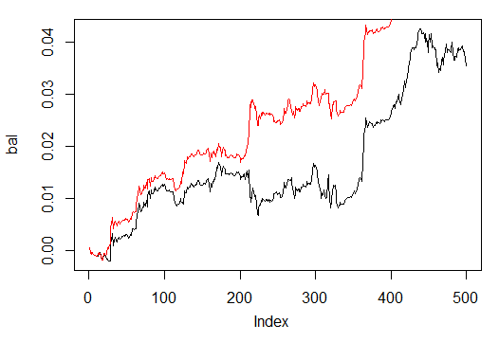
Fig. 32. Balance on the last 500 bars by the signals of neural networks trained in 500 and 300 epochs
图32 最后500根K线数据经过500和300期神经网络训练信号后的余额
As we can see, neural network trained in 300 epochs, showed a better result than the network trained in 500 epochs.
我们可以看到，神经网络训练300期，表现出比训练500期更好的结果。
The training time of the latter is suitable for quick retraining during a trading session on this timeframe.
后者的训练时间是适合快速培训期间的交易时段的这段时间。
For further work on a real chart we need two objects: trained model "SAE" and normalization parameters "prepr" for input data. Save them in the relevant directory, in my case this is "D:/Alpari Limited MT4/MQL4/Files/EURUSD/M30/Test_2014-10-14". This is defined and operates as a working one, if you opened in RStudio the "i_SAE_EURUSD_30.Rdata" working area saved by the indicator.
进一步的工作将在一个真实的图表，我们需要两个对象：训练模型“SAE”和归一化参数输入数据“prepr”。它们保存在相关的目录，对我来说这是"D:/Alpari Limited MT4/MQL4/Files/EURUSD/M30/Test_2014-10-14"。如果你在RStudio中打开"i_SAE_EURUSD_30.Rdata"，用指标保存工作区,这是定义和操作的一个选择。
save(SAE, prepr, file="SAE.model")
In the "SAE.model" file, we saved the model itself and normalization parameters. Using the model without them does not make sense. You can experiment and save the models you like every day. They will be saved in the folders "/File/Symbol/TF/Test_Data". For the EA to use the model, put the "SAE.model" file to the folder "File/Symbol/TF/" manually. This folder can contain only one model and the EA will use it for work.
在"SAE.model" 文件中，我们保存了模型本身和归一化参数。没有他们去使用模型是没有意义的。你可以每天试验和保存模型。他们将被保存在"/File/Symbol/TF/Test_Data"。对于EA使用模型，把"SAE.model"文件手动移动到"File/Symbol/TF/"文件夹。这个文件夹可以包含和EA只有一个模型将用它工作。
Having loaded the "SAE.model" file, the EA loads these objects to the working area for using in work. At this point the manual part of the work is finished, you can place the indicator-EA to the chart and test it in real time.
加载"SAE.model"文件，EA加载这些对象到工作区中为了在工作中使用。在这一点上，手动部分工作完成，你可以把指标和EA加载在图表中并实时测试。
To assess the effectiveness of the EA's work, quantitative criteria are required. The Accuracy coefficient is not quite suitable for this purpose.
对EA的工作成效，需要量化标准。精度系数不完全适用于这个目的。
The average of the balance forecast ratio received by ZigZag and the balance ratio on the last bar to the number of bars. In our case this is the balance by ZigZag:
ZigZag和最后一根K线与K线数的比接收余额预测比的平均值。以下是我们使用ZigZag处理余额比的情况：
sig.zz<-ifelse(tail(dt[ , ncol(dt)], 500) == 0, 1, -1)
bal.zz<-cumsum(tail(price[ , 'CO'], 500) * sig.zz)
Kzz<-mean(bal.zz / bal)
> Kzz
[1] 0.9173312
This is a very high score but it is relative. 这是一个非常高的得分，但这是相对的。
If we see what it looks like over time, we can see that for the first 50-100 bars this is an unstable index, though later it becomes nearly constant. Statistics are below:
如果我们看起来这个好像是时间相关的，我们可以看到对于最初的50到100根K线，有一个不稳定的指标，尽管之它变得几乎为常量。统计如下：
> plot(bal/bal.zz, t="l")
> summary(bal/bal.zz)
Min. 1st Qu. Median Mean 3rd Qu. Max.
-15.2500 0.7341 0.7844 0.9173 0.8833 55.0000
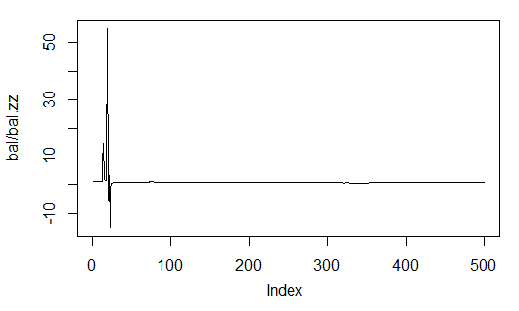
Fig. 33. Ratio of the forecast balance to the balance obtained by ZigZag
图33 预测的余额与余额ZigZag比
The second one is more precise as it shows how many points of profit there are for one bar on a stretch N bars long.
第二个就像它展现的那样更精确的说明在一条延伸的N根K线中有多少个盈利点。
For example, for the balance by neural network forecast on the stretch of 500 bars:
例如，对于余额的500根延伸的神经网络预测：
> Kb<-tail(bal,1)/length(bal)*10^Dig
> Kb
[1] 11.508
by ZigZag signals: ZigZag信号：
> Kbz<-tail(bal.zz,1)/length(bal)*10^Dig
> Kbz
[1] 13.784
When the lower limit of effectiveness on one of the parameters is defined, we know the time when we can retrain the neural network or optimize its parameters.
当有效性的下限被定义为一个参数，我们就知道什么时候来重新训练神经网络或者优化参数。
The EA will display the following parameters on the chart: OP – executed operation, Acc – Accuracy, K – is Kb defined earlier, Kmax – the same parameter as Kb but defined on the balance high and gives an idea of how much this parameter differs on the last bar from the maximal one.
EA将在图表显示下列参数：OP–执行的操作，Acc–精度，K–是Kb的早期定义，Kmax–相同的Kb参数，但定义在余额高点，而且给出了一个关于这个参数在最后一根K线与最大一根差距的想法。
4.2. In the attached archive SAE.zip you can find: 安装和启动顺序:
- The i_SAE.mq4 indicator, put to the ~/MQL4/Indicators/ folder
i_SAE.mq4指标文件放入~/MQL4/Indicators/文件夹
- The e_SAE.mq4 EA, put to the ~/MQL4/Experts/ folder
e_SAE.mq4 EA文件放入~/MQL4/Experts/文件夹
- The mt4Rb7.dll library, put to the ~/MQL4/Libraries/ folder.
mt4Rb7.dll库文件放入~/MQL4/Libraries/文件夹
- The mt4Rb7.mqh header file, put to the ~/MQL4/Include/ folder. The library and header file were developed and kindly provided by Bernd Kreuss. The name includes the index of the last change (b7). When there are a lot of versions with the same names, there are confusions that take a lot of time to rectify.
mt4rb7.mqh头文件放入~ / MQL4 /Include/文件夹。库文件和头文件由Bernd Kreuss开发和热心提供。文件名包含了上次变化的序号(b7)。有很多相同名字的版本，造成需要花很多的时间来纠正的麻烦。
- Scripts on R: i_SAE.r (main indicator script), i_SAE_fun.r (functions of the indicator script), e_SAE.r (EA script), e_SAE_init.r (EA initialization script), SAE_SetDir.r (script of validation and creation of necessary directories). As scripts depend neither from the symbol, nor from a timefreame, they can be located in a separate directory. In my case this is "C:Rdata/SAE/". The "C:Rdata/" directory contains different scripts not attached to any certain project. If you put scripts in a folder different from mine, then make appropriate corrections in the indicator and EA that is correct the way to the scripts.
R上运行的脚本：i_SAE.r(主要指标脚本)，i_SAE_fun.r (指标脚本函数), e_SAE.r (EA脚本), e_SAE_init.r (EA初始化脚本), SAE_SetDir.r (验证和创建必要目录的脚本)。脚本既不依赖商品，也不依赖时图，可以被放置在一个单独的目录中。我是放在"C:Rdata/SAE/"。"C:Rdata/"目录包含不附加到任何项目的不同的脚本。如果你把脚本放在一个不同的文件夹，就需要在指标和EA文件中进行连接到次目录相应的修正。
- SAE.model is a file with the "SAE" model and normalization parameters "prepr". The model was trained on EURUSD (M30), last date 14.10.14. The training process was described above.
SAE.model是一个包含“SAE”模型和归一化参数的的“prepr”。此模型在EURUSD（M30）上被训练，最后训练日期是2014年10月14日。之前介绍过此训练的进程。
Also do not forget the way to the directory where the R language was stored on your computer.
也不要忘记去连接存储在您的计算机里R语言的目录。
The following order is preferable to follow to start working. Place the EA on the chart. If you decide to place an EA on another symbol, a port, different from previously launched servers is to be specified. For instance, port 8886 (by default port 8888).
以下的顺序更好排列开始工作后的次序。EA挂在图表中。如果你打算把一个EA挂在另一个商品，需要设置一个不同于之前使用的服务器的端口。例如，端口8886（默认端口8888）。
Note. This is an absolutely inefficient way. Every server has a size of 120-130 Mb. This is what things are today.
注：这绝对是一个低效率的方式。每个服务器都有一个大小为120-130 MB的空间。这是现在的情况。
After normal EA initialization, the alert "No calculation results! Symbol" will appear. Then install the indicator with external parameter send = true and specified server port that the indicator is to connect to (see above). If everything works correctly, the real data "operation", Accuracy, K and Kmax will appear in the output string and trading will start.
正常的EA初始化后，警报"No calculation results! Symbol"将出现。然后安装指标与外部参数send = true，指定的服务器指标连接的端口，（见上）。如果一切正确，真实的数据“运作”，精度K和Kmax将出现输出字符串，交易开始进行。
Efficient control of the process can be best facilitated from the Windows Task Manager. If Rterm does not appear in the list after the EA or indicator was launched, then the R process was disrupted. The main reason of such disruptions is a syntax error in scripts, mismatch of the length of the receiving MQL vector and the vector extracted from Rterm.
进程的有效控制可以得到Windows任务管理器最好的帮助。如果EA或者指标运行后，Rterm没有出现在列表中，R进程就被干扰了。这些干扰的主要原因是脚本语法错误，从MQL接收的向量和从Rterm提取向量的长度不匹配。
Scripts can be debugged in RStudio by launching scripts line by line from the beginning to the end.
脚本可以在RStudio运行，并从头至尾逐行的调试。
Unfortunately I was unable to launch the EA in the tester, therefore it has to be tested on a demo account.
遗憾的是，我无法在测试中运行EA，因此它必须在一个模拟账户中测试。
4.3. Ways and Methods of Improving Qualitative Characteristics提高质量特征的途径和方法
- Change the set of the indicators used at the input. 改变输入时应用指标的设置
- Change the way of the input data normalization. 改变输入数据的归一化方法。
- Optimize parameters of the "supervisor" and indicators at the input. 优化输入时的“监督”和指标参数。
- Change the coding of the input variable for the matrix with two columns. Calibrate the forecast signal. 改变输入变量的编码为两列矩阵。校准预测信号。
- Optimize the network parameters (number of neurons in the hidden layers, number of layers, level of learning, number of epochs). 优化网络参数（隐藏层神经元数，层数，学习水平，历元数）。

Conclusion结论
We have created, trained and tested deep network models with initialization of the neuron weights in the hidden layers from SAE. Networks retrain very quickly and it allows to retrain them without disrupting the trading process.
我们已经在隐藏层SAE的神经元权值初始化后创建、训练和测试了深度网络模型。网络训练速度很快，可以重新训练也不破坏交易进程。
The results shown by neural networks are average in terms of metrics. The ideal result was not the initial goal.
结果表明神经网络是平均值。理想的结果并非最初的目标。
Using such a model and permanent evaluation of the effectiveness coefficient, the model can be retrained and optimized without disrupting the trading process.
使用这样的模型和有效性系数的永久评估，模型可以在不影响交易进程情况下重新训练和优化。
Attachment: 附件：
- SAE.zip - indicator, EA and accompanying files.
- R_intro.zip - literature on R and Rstudio in Rusian.
- DeepLearning.zip - literature of Deep Learning.

Translated from Russian by MetaQuotes Software Corp. 俄/英翻译由MetaQuotes软件公司完成。
Original article: https://www.mql5.com/ru/articles/1103 原文章链接
Attached files | 附加文件
Download ZIP
deeplearning.zip (6542.81 KB)
r-intro.zip (15278.8 KB)
sae.zip (394.31 KB)
Warning: All rights to these materials are reserved by MQL5 Ltd. Copying or reprinting of these materials in whole or in part is prohibited.
警告：所有的这些材料的版权由MQL5公司所有。复制或转载这些材料的全部或部分都被禁止。

笔记：
2016-01-05
所需包：
- deepnet
- TTR
- caret
- rminer
- foreach
- doParallel
- svSocket
2016-01-07
训练SAE.model必须要在RStudio里完成

